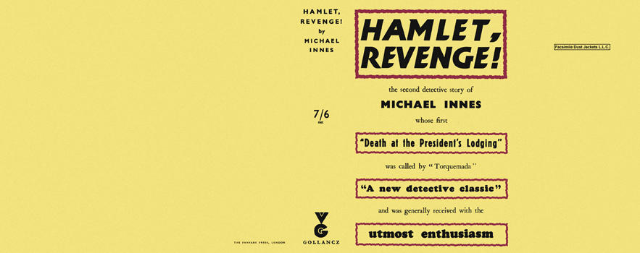

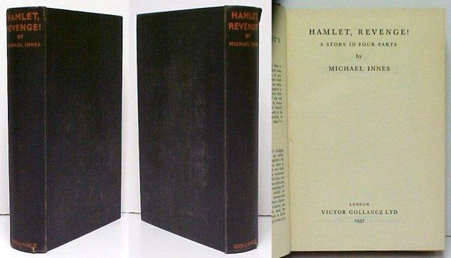

Innes, Michael
Hamlet, revenge!
V. G. Gollancz (UK) (1937) first printing.

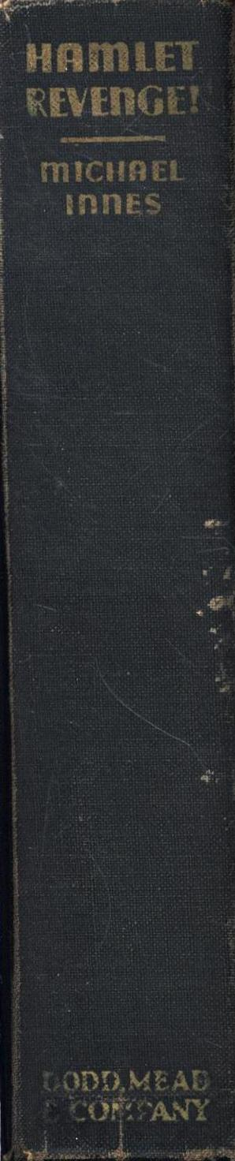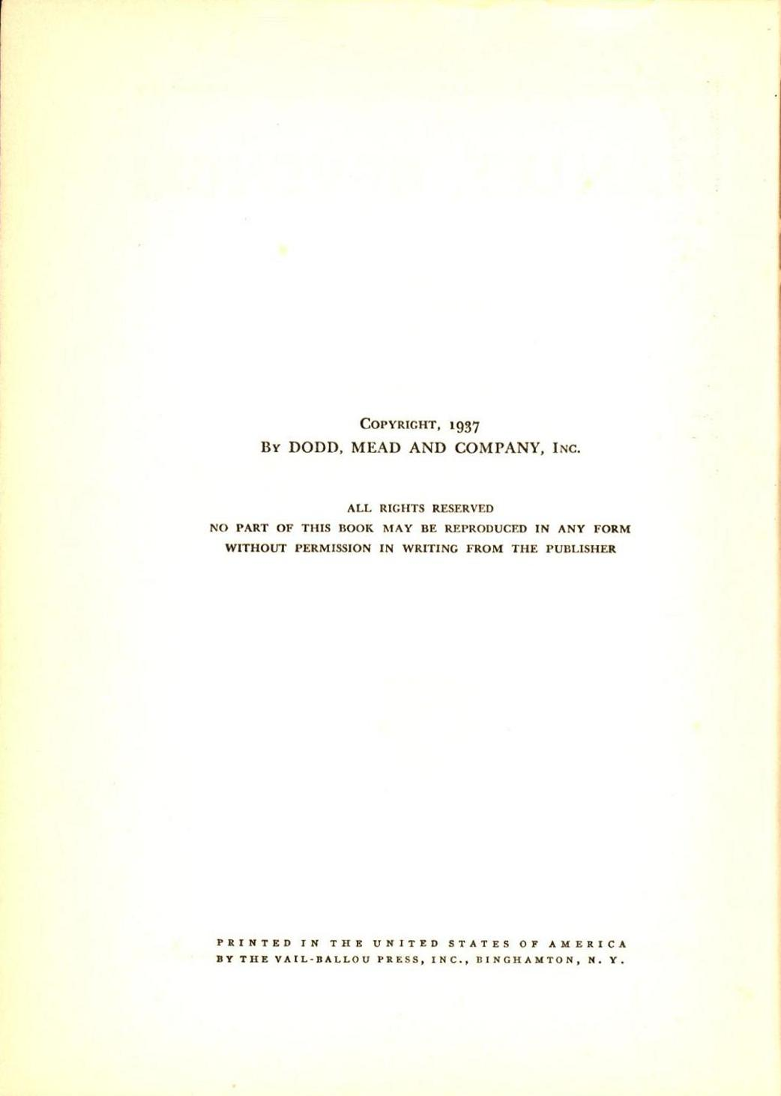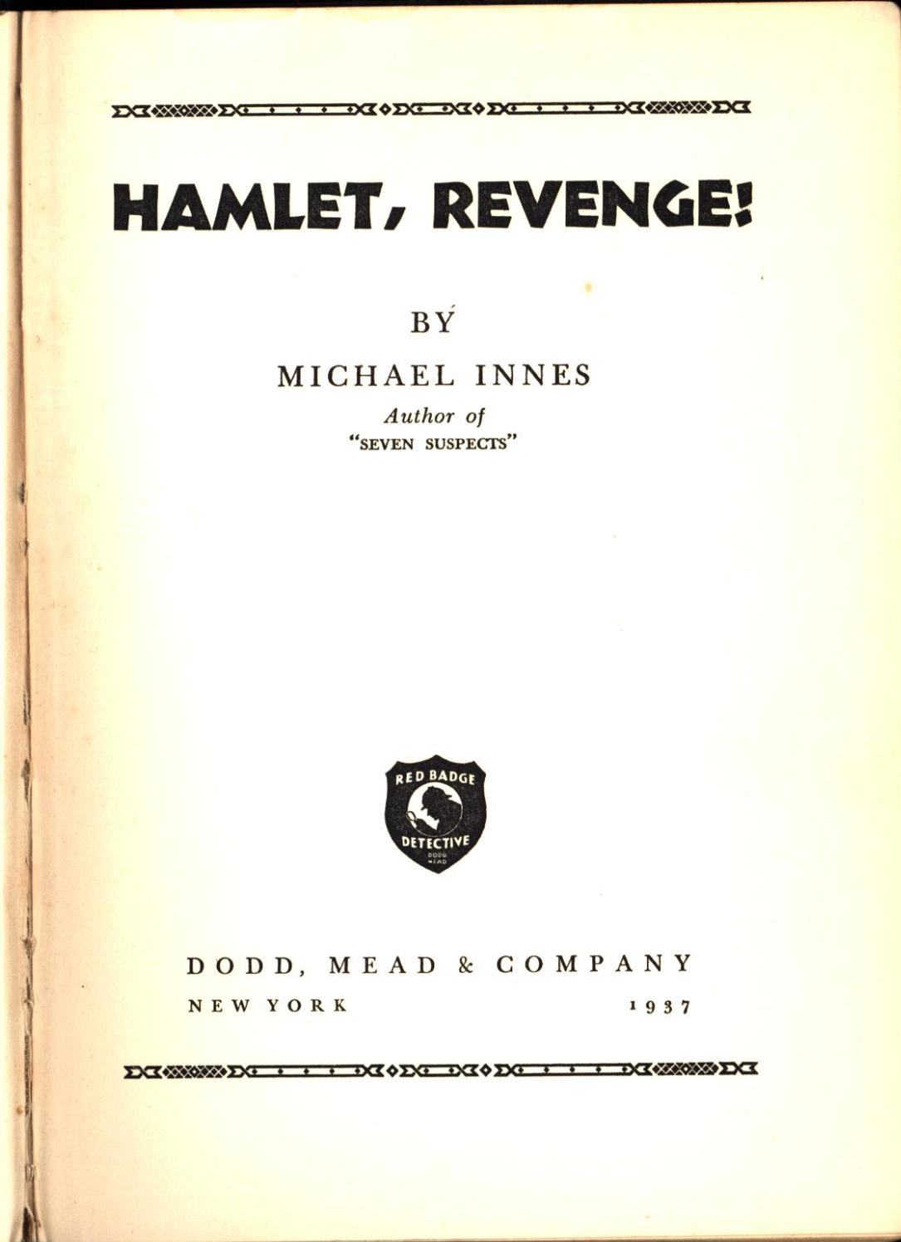

Innes, Michael
Hamlet, revenge!
Dodd, Mead and company (USA) (1937) first printing

Суперобложка и внешний вид первых изданий романа

