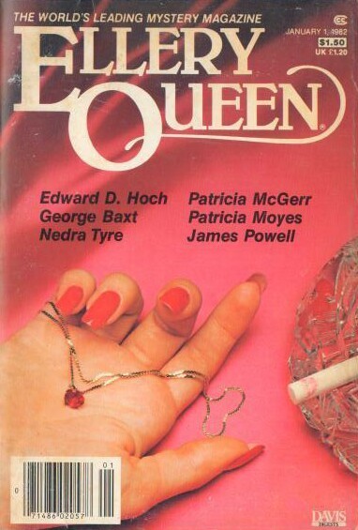

Ellery Queen’s Mystery Magazine
[v79 #1, Whole No. 461, January 1, 1982]

  - 7 · Who Killed Father Christmas? · Patricia Moyes · ss Who Done It? ed. Alice Laurance & Isaac Asimov, Houghton Mifflin, 1980
  - 16 · Anything Goes · Donald Olson · ss
  - 30 · The Priest Without a Shadow [Ambrose Ganelon] · James Powell · ss
  - 45 · Show Business · George Baxt · ss
  - 56 · The Bloody Mustache · Patricia McGerr · ss
  - 64 · The Way to Hunt Tigers · Jeffry Scott · ss
  - 75 · The Spirit Sword · Ta Huang Chi · ss
  - 90 · They Shouldn’t Uv Hung Willie · Nedra Tyre · ss Red Wine First by Nedra Tyre, Simon & Schuster, 1947
  - 102 · The Inquest at Crossbury · John H. Dirckx · ss
  - 115 · Final Turn · Clements Jordan · ss
  - 121 · The Shape of the Nightmare · Francis M. Nevins, Jr. · ss
  - 138 · Dereliction of Duty · Henry T. Parry · vi
  - 141 · The Problem of the Gypsy Camp [Dr. Sam Hawthorne] · Edward D. Hoch · ss

Обложка журнала, в котором впервые был напечатан рассказ

