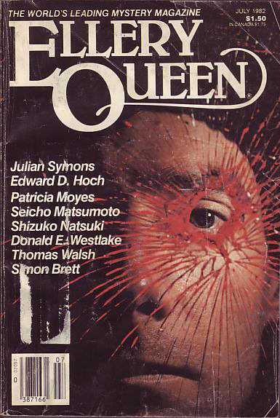

Ellery Queen’s Mystery Magazine
[v80 #1, Whole No. 467, July 1982]

  - 5 · The Flaw · Julian Symons · ss Winter’s Crimes 11 ed. George Hardinge, Macmillan, 1979
  - 22 · Re Porter · Donald E. Westlake · ss
  - 36 · Hit and Run · Patricia Moyes · ss
  - 41 · Sitting Duck · Thomas Walsh · ss
  - 53 · The Humble Coin · Seicho Matsumoto · ss
  - 63 · Once More the Butler · Ted Singer · ss
  - 69 · The Vigil of Death [Ambrose Ganelon] · James Powell · nv
  - 90 · Where Were You, Mamie? · Mary Amlaw · ss
  - 109 · Two Birds with One Stone · Dan J. Marlowe · ss
  - 115 · I Can’t Help Loving Him · Shizuko Natsuki · ss
  - 132 · Privileged Information · Simon Brett · ss
  - 140 · The Problem of the Bootlegger’s Car [Dr. Sam Hawthorne] · Edward D. Hoch · ss

Обложка журнала, в котором впервые был напечатан рассказ

