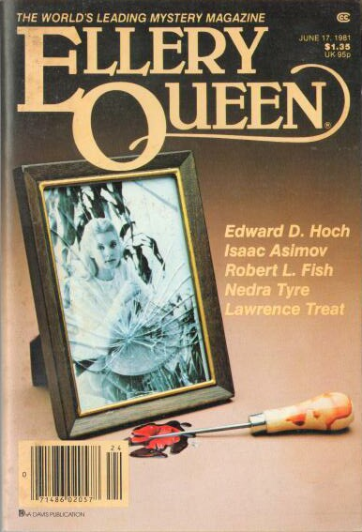

Ellery Queen’s Mystery Magazine [v77 #7, #454, June 17, 1981]

  - 6 · Can You Prove It? [Black Widowers] · Isaac Asimov · ss
  - 20 · Won’t Daddy Be Surprised? · Clements Jordan · vi
  - 23 · Mr. Strang Unlocks a Door [Leonard Strang] · William Brittain · ss
  - 37 · How Does Your Garden Grow? · Anthony Bloomfield · ss
  - 42 · A Friend Who Understands · Donald Olson · ss
  - 53 · Look of Eagles · Jo Lockwood · ss
  - 68 · What Time Do the Pyramids Open? · Betty Jochmans · ss
  - 78 · Grampaw Lends a Hand · Robert J. Cloud · ss
  - 91 · Mr. Smith and Myrtle · Nedra Tyre · ss Red Wine First, Simon & Schuster 1947
  - 100 · The Adventure of the Pie-Eyed Piper [Schlock Homes] · Robert L. Fish · ss
  - 108 · The Decline and Fall of Norbert Tuffy [Adman] · Ron Goulart · ss
  - 120 · Concerto for Voilence and Orchestra · William Bankier · ss
  - 129 · M as in Mayhem [Mitch Taylor; Bill Decker] · Lawrence Treat · ss
  - 140 · The Problem of the Pink Post Office [Dr. Sam Hawthorne] · Edward D. Hoch · ss

Обложка журнала, в котором был напечатан рассказ

