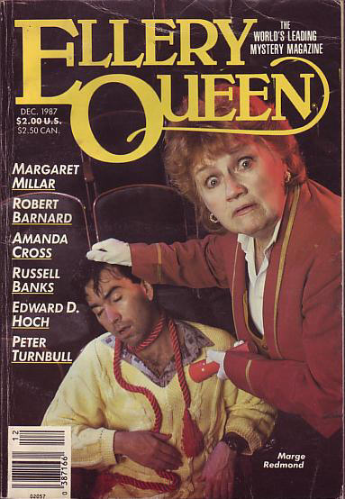

Ellery Queen’s Mystery Magazine [v90 #6, #537, December 1987].

  - fc. · [photo of Marge Redmond] · Anon.
  - 6 · The Problem of the Snowbound Cabin [Dr. Sam Hawthorne] · Edward D. Hoch
  - 23 · To His Credit · James G. Holding
  - 29 · The Thin White Line · Jay A. Cohen
  - 39 · Notions · Margaret Millar
  - 44 · Jojo and the Fish-hooks Pocket [Joy Lorraine “Jojo” Paxton] · Jeffry Scott
  - 56 · Billie Loses Her Job · Robert Henson
  - 80 · The Jury Box · Allen J. Hubin
  - 83 · The Woman in the Wardrobe · Robert Barnard
  - 98 · Doctor Wickshaw · Russell Banks
  - 104 · Arrie and Jasper [Kate Fansler] · Amanda Cross
  - 120 · Not Much of a Trade · Brendan DuBois
  - 133 · All in Scarlet When She Died [P Division] · Peter Turnbull

Обложка журнала, в котором был напечатан рассказ

