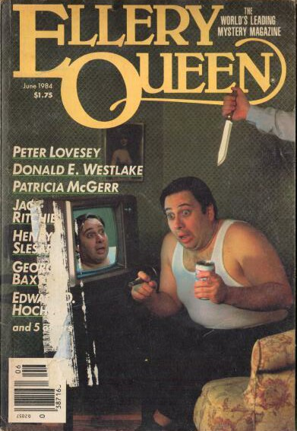

Ellery Queen’s Mystery Magazine
[v83 #6, Whole No. 492, June 1984]

  - 6 · The Problem of the Graveyard Picnic [Dr. Sam Hawthorne] · Edward D. Hoch · ss
  - 20 · Call Him Ishmael · George Baxt · ss
  - 28 · Detectiverse: Justifiable Homicide · Helen Thilenius · pm
  - 30 · Fallout · Peter Lovesey · ss Company May 1983
  - 43 · The Two Percent Solution [Henry Turnbuckle] · Jack Ritchie · ss
  - 51 · The Nice One · William Bankier · ss
  - 62 · Mystery Newsletter · R. E. Porter & Chris Steinbrunner · cl
  - 66 · The Jury Box · Allen J. Hubin · rc
  - 68 · Detectiverse: Stop Me if You’ve Heard This · Phyllis White · pm
  - 69 · The Same Cloth · Edith Green · ss
  - 76 · By the Book · Lee Barwood · ss
  - 81 · Detectiverse: Misogynist Mysteries · Bernard Blicksilver · pm
  - 82 · The Tin Man · Henry Slesar · ss
  - 96 · A Nice Thing Going · Robert Edward Eckels · ss
  - 108 · The Steep Dark Stairs · Ian Stuart · ss
  - 120 · Fatal Corner · Patricia McGerr · ss
  - 127 · After I’m Gone [Abe Levine] · Donald E. Westlake · nv
  - 153 · Index to Volume 83 · [uncredited] · ix
  - 163 · Detectiverse: Belladonna · Isaac Asimov · pm Murder Ink: The Mystery Reader’s Companion ed. Dilys Winn, Workman Publishing, 1977
  - 163 · Detectiverse: Botulism · Isaac Asimov · pm Murder Ink: The Mystery Reader’s Companion ed. Dilys Winn, Workman Publishing, 1977
  - 163 · Detectiverse: Curare · Isaac Asimov · pm Murder Ink: The Mystery Reader’s Companion ed. Dilys Winn, Workman Publishing, 1977

Обложка журнала, в котором впервые был напечатан рассказ

