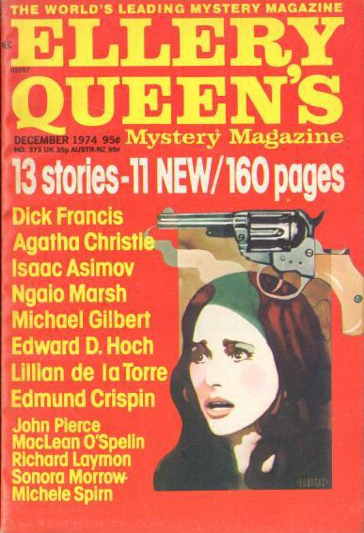

Ellery Queen’s Mystery Magazine
[v64 #6, Whole No. 373, December 1974]

  - 7 · The Big Story · Dick Francis · nv Sports Illustrated May 7 1973, as “A Day of Wine and Roses”
  - 26 · Confessions of an American Cigarette Smoker [Black Widowers] · Isaac Asimov · ss
  - 42 · Death and Aunt Fancy [Gervase Fen] · Edmund Crispin · ss Collier’s April 25 1953
  - 46 · Department of Problems Resolved: Operation Gimmick · MacLean O’Spelin · ss
  - 60 · Roadside Pickup · Richard Laymon · ss
  - 65 · Who Has Seen the Wind? [Patrick Petrella] · Michael Gilbert · ss Argosy (UK) November 1956
  - 73 · Walking Hubert Down · John Pierce · nv
  - 92 · Strange Jest [Miss Marple] · Agatha Christie · ss This Week November 2 1941
  - 102 · Crossword Puzzle: To Dame Agatha with Love · Jack Luzzatto · pz [Ref. Agatha Christie]
  - 104 · Murder in the Pantry · Michele Spirn · ss [Ref. Agatha Christie]; in EQMM’s “Department of First Stories”. Parody of Agatha Christie’s Miss Marple.
  - 114 · A Fool About Money · Ngaio Marsh · ss
  - 119 · The Lost Heir [Dr. Sam: Johnson] · Lillian de la Torre · nv
  - 137 · The Jury Box · John Dickson Carr · rc
  - 139 · Hard Times · Sonora Morrow · vi
  - 140 · The Problem of the Covered Bridge [Dr. Sam Hawthorne] · Edward D. Hoch · nv
  - 161 · Index to Volume 64 · [uncredited] · ix

Обложка журнала, в котором впервые был напечатан рассказ

