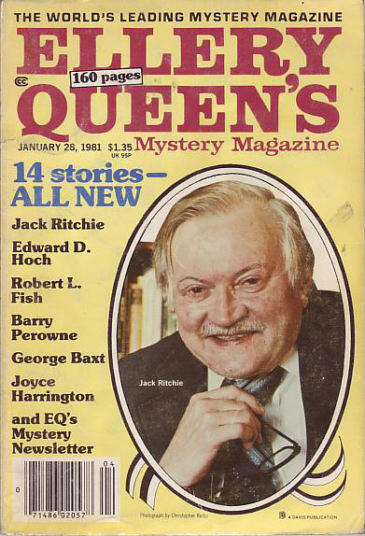

Ellery Queen’s Mystery Magazine
[v77 #2, Whole No. 449, January 28, 1981]

  - 6 · The Absence of Emily · Jack Ritchie · ss
  - 16 · The Yorkshire Ripper · Mary Braund · ss
  - 26 · The Black Stain · Henry T. Parry · ss
  - 44 · Maybe It Didn’t Happen · Robert Edward Eckels · ss
  - 48 · The Adventure of the Ukrainian Foundling Orphans [Schlock Homes] · Robert L. Fish · ss
  - 56 · Father Sherlock · Aubrey Davidson · pm
  - 58 · The Adventure of the Hare Apparent · Hal Charles · vi
  - 59 · The Girl Downstairs · Florence V. Mayberry · ss
  - 70 · Raffles and the Box 4 Drama [A.J. Raffles] · Barry Perowne · nv
  - 91 · Mystery Newsletter · Otto Penzler & Chris Steinbrunner · cl
  - 93 · Interview: Robert Twohy · [uncredited] · iv [Ref. Robert Twohy]
  - 96 · The Jury Box · Jon L. Breen · rc
  - 99 · Whatever Will Become of George? · Ellen Betty Brink · vi
  - 101 · Something Is Going to Happen · Sharon Evans · ss
  - 112 · Dispatching Bootsie · Joyce Harrington · ss
  - 126 · A Schoolteacher’s Lot · Clements Jordan · ss
  - 135 · What You Been Up to Lately? · George Baxt · ss
  - 142 · Detectiverse: A Man of Convictions · William F. Smith · pm
  - 143 · The Problem of the Gingerbread Houseboat [Dr. Sam Hawthorne] · Edward D. Hoch · ss

Обложка журнала, в котором впервые был напечатан рассказ

