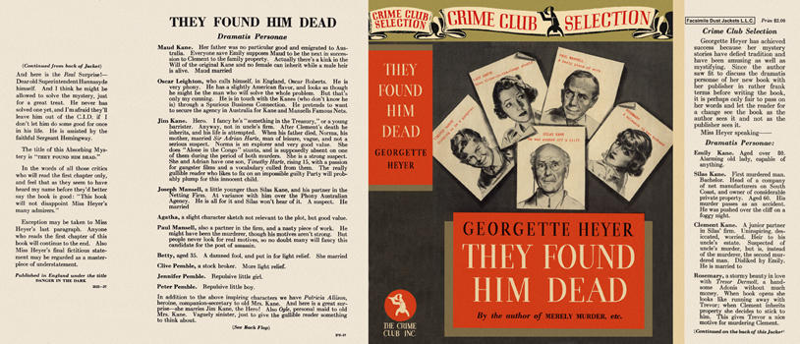

Heyer, Georgette
They found him dead
Doubleday The Crime Club (USA), 1937
first printing

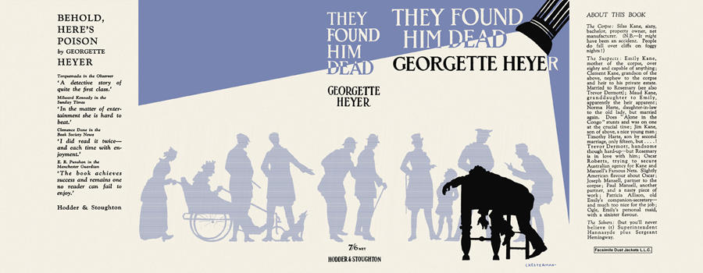

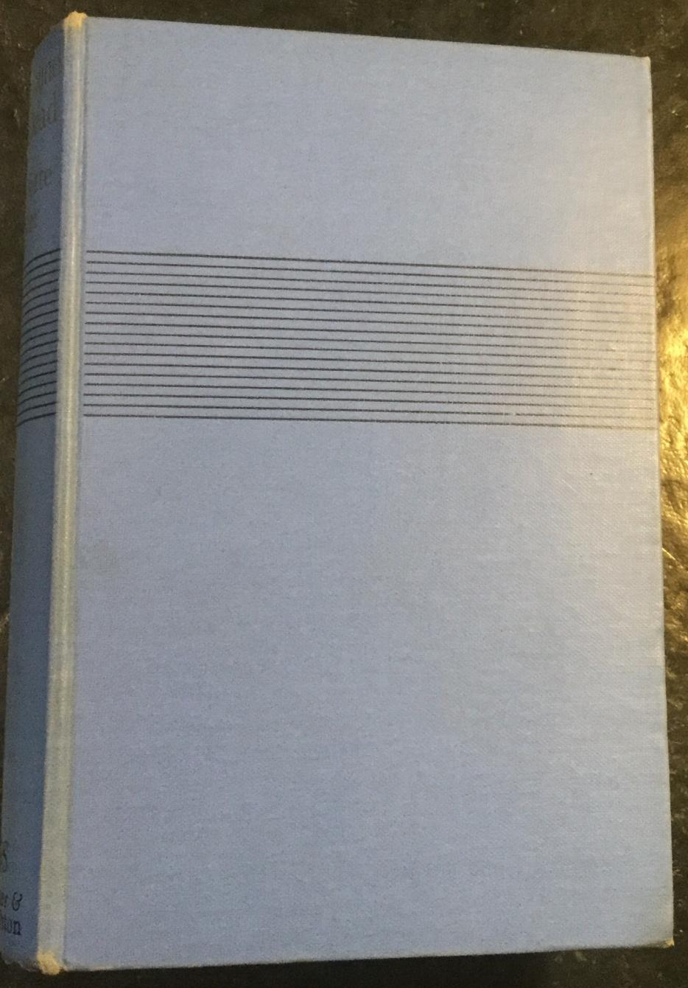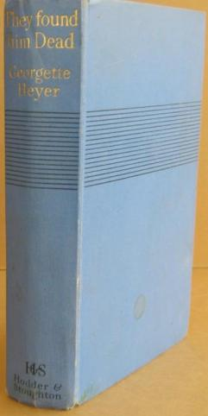

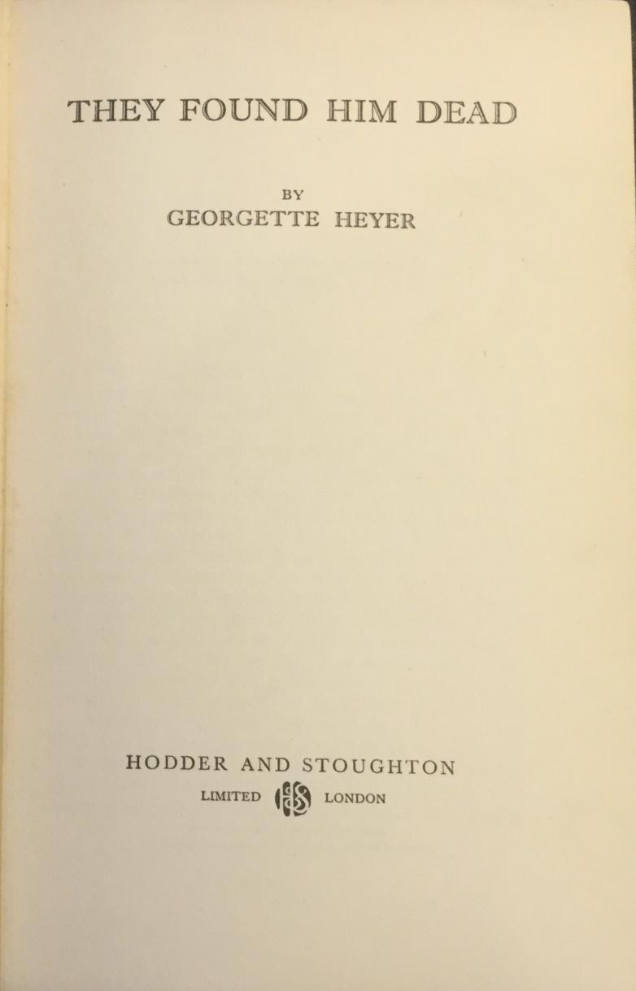

Heyer, Georgette
They found him dead
Hodder & Stoughton (UK), 1937
first printing

Внешний вид первых изданий книги

