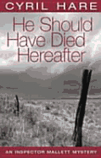

Hare, Cyril

He should have died hereafter
Faber and Faber (UK) (1958) first edition

Обложка первого издания романа

