

Freeman, R. Austin
The eye of Osiris
Hodder and Stoughton (UK) (1911) pre-publication

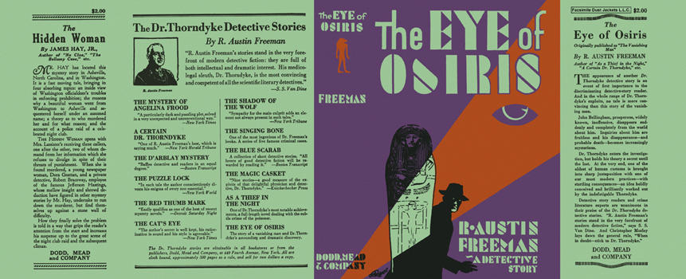

Freeman, R. Austin
The eye of Osiris
Dodd, Mead and Company (USA) (1911) 1929 reprint

Суперобложки первых изданий романа

