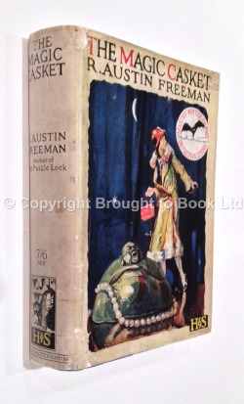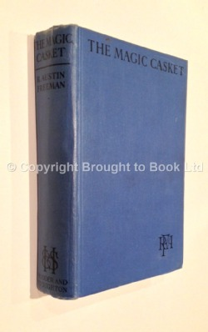

Freeman R.A. The magic casket. L.: Hodder and Stoughton, 1927

