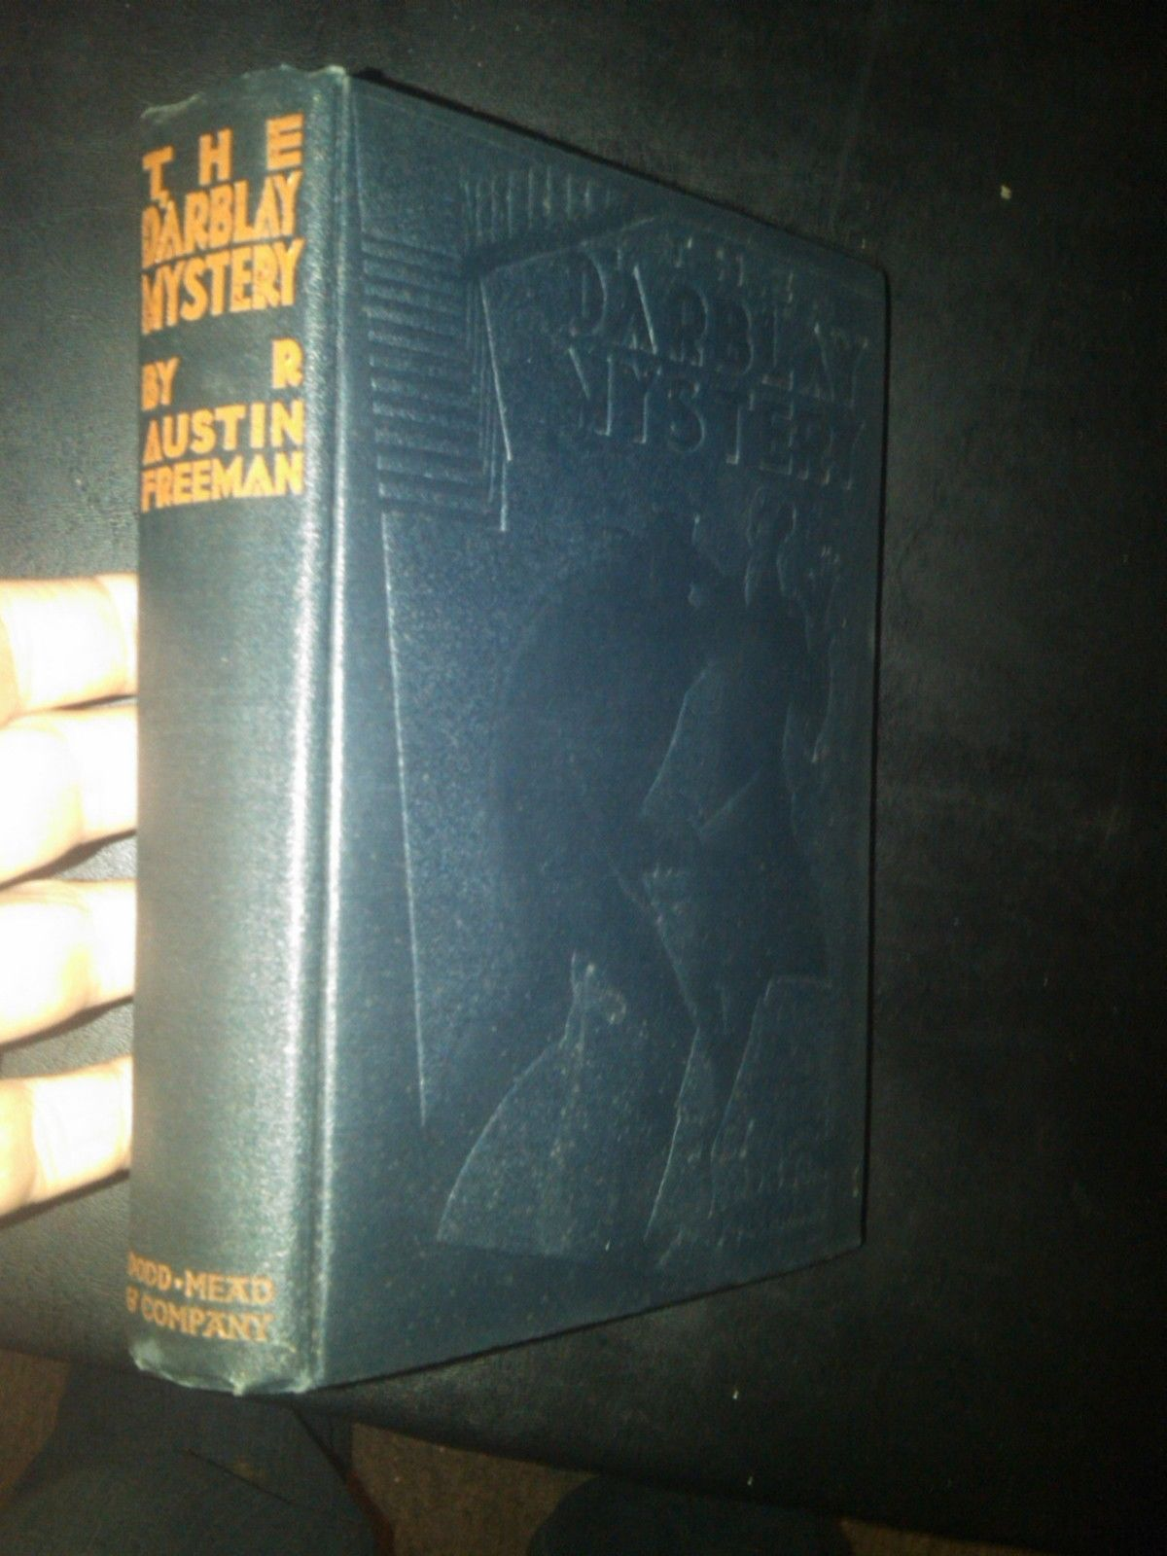

Freeman R.A. The D’Arblay mystery. New York: Dodd Mead & Company, 1926

