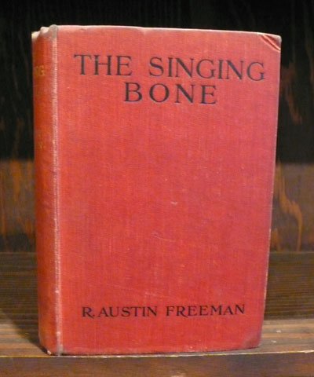

Freeman R.A. The singing bone. L.: Hodder and Stoughton, 1912

