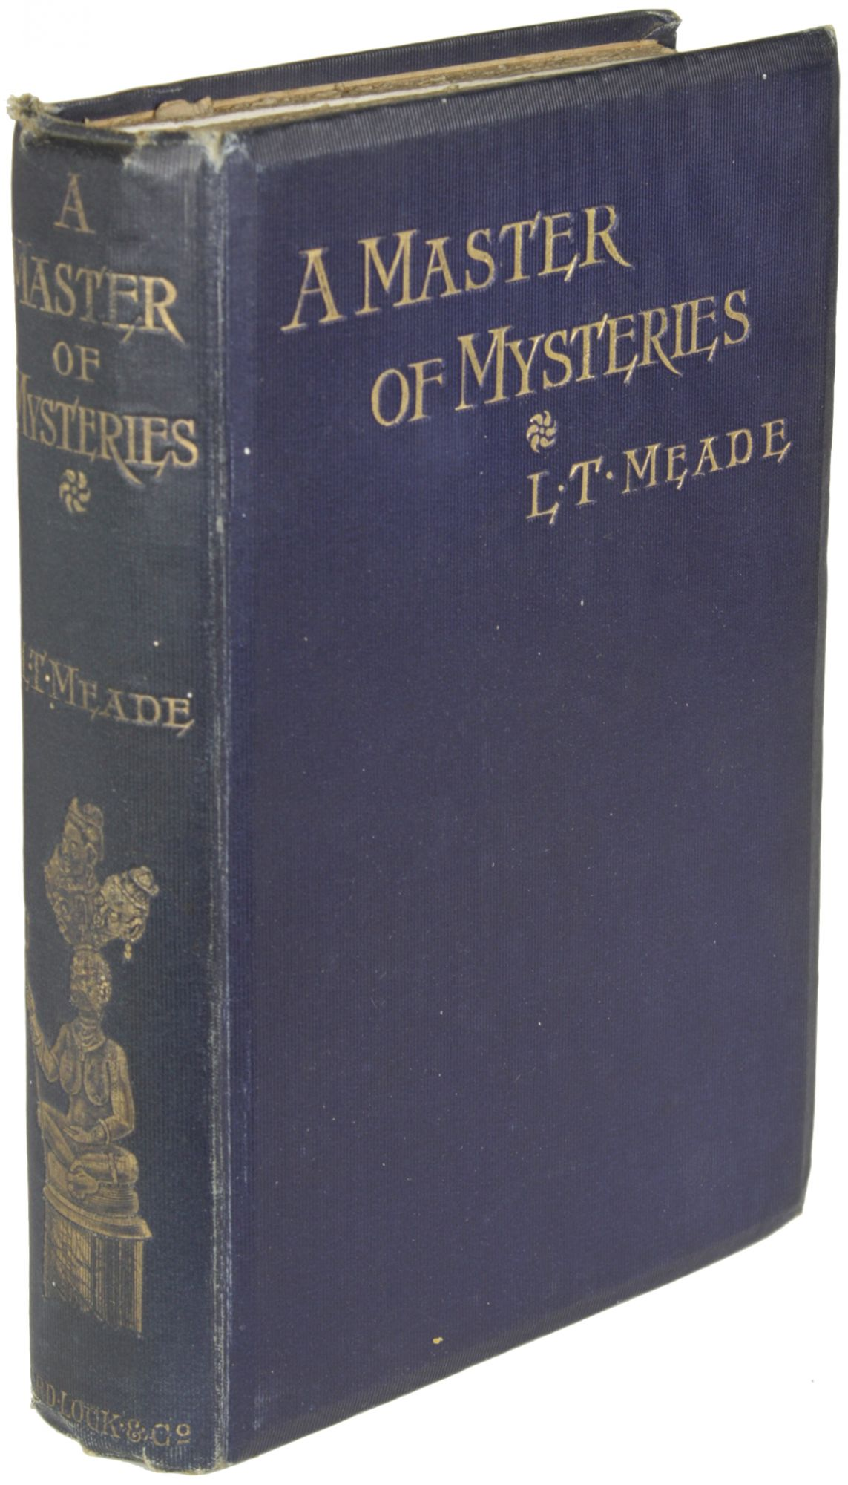

Meade, L. T. and Robert Eustace
A master of mysteries
London, New York and Melbourne: Ward, Lock & Co Limited, n.d. [1898]

Внешний вид первого издания книги

