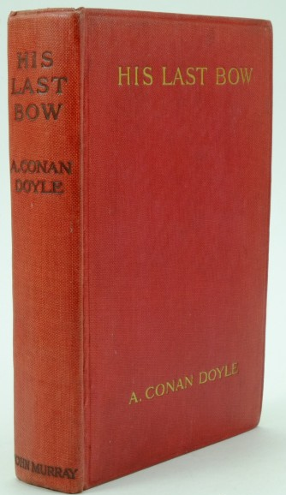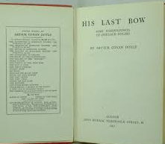

Doyle, Sir Arthur Conan
His last bow
London: John Murray, 1917
first printing
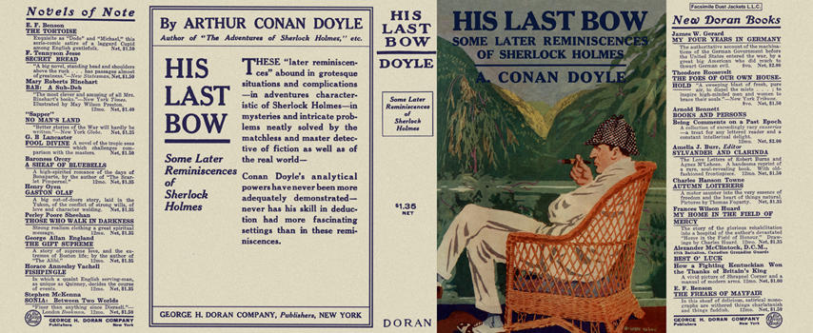

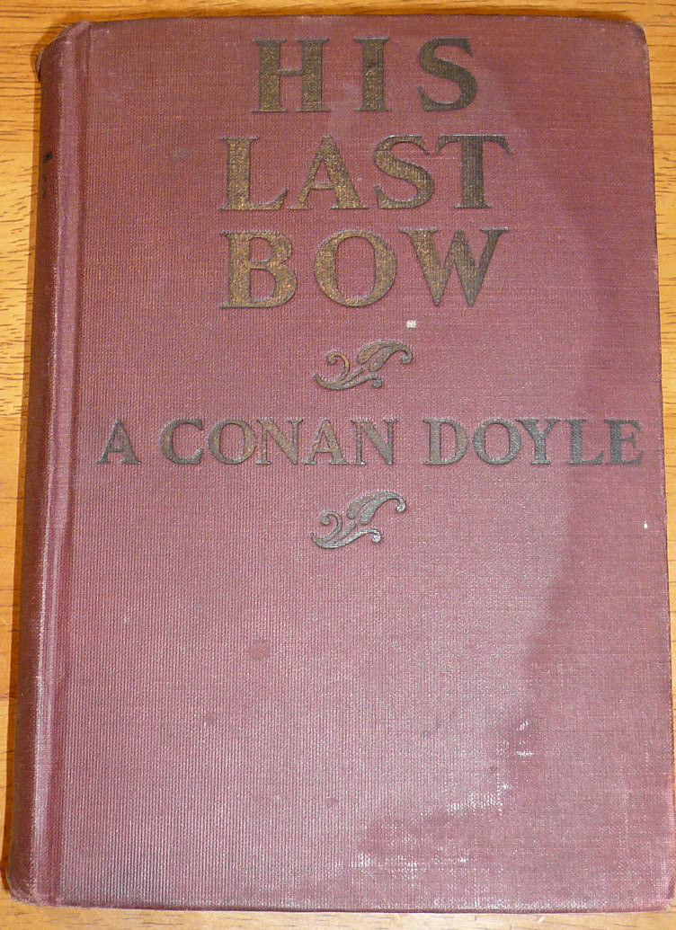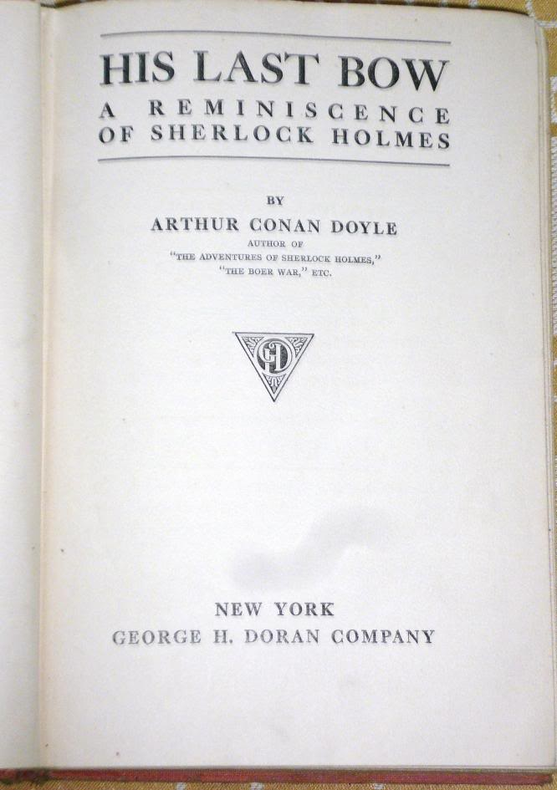

Doyle, Sir Arthur Conan
His last bow
George H. Doran Company (USA), 1917
first printing

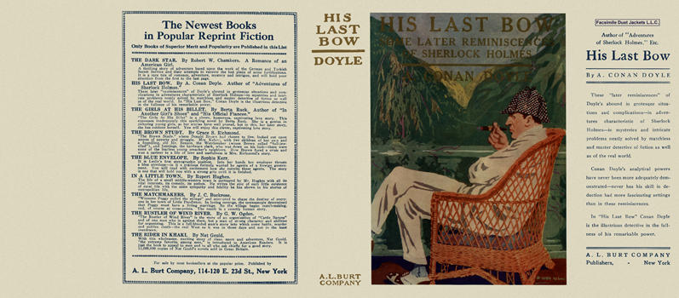

Doyle, Sir Arthur Conan
His last bow
A. L. Burt Company (USA), 1917

Внешний вид первых изданий книги

