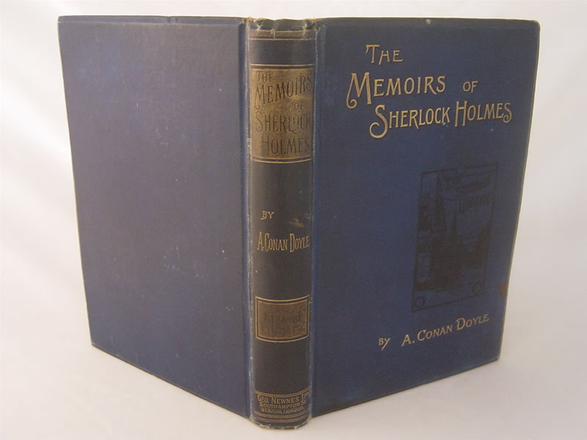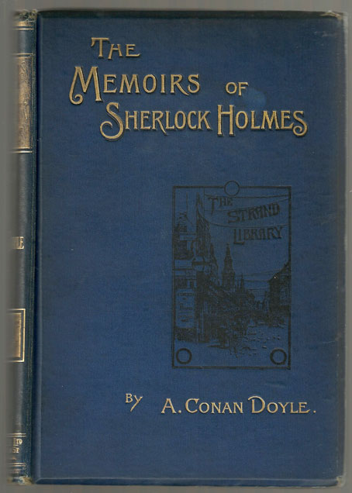

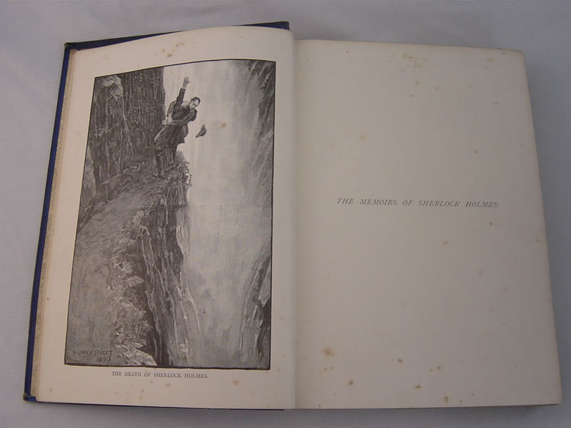

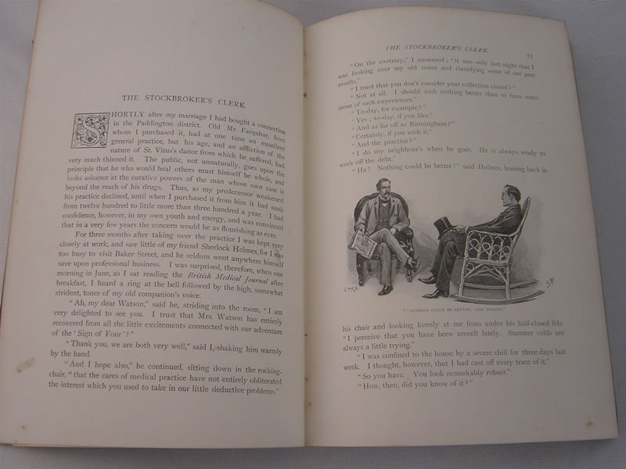

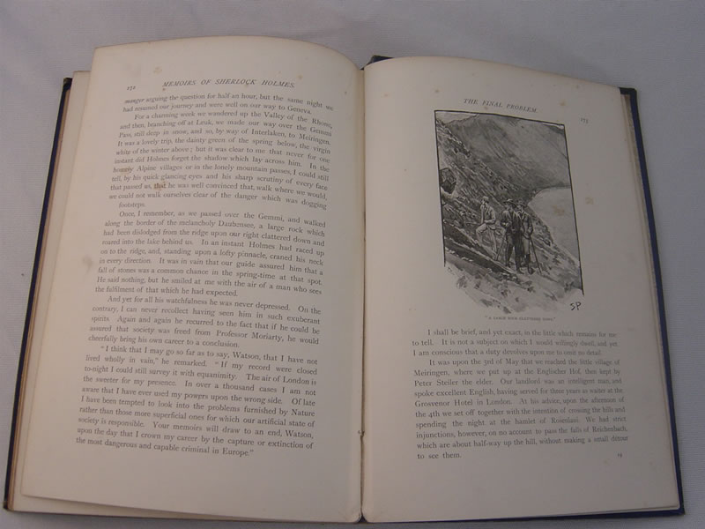

Doyle, Sir Arthur Conan
Memoirs of Sherlock Holmes

London: George Newnes Limited, 1894
With illustrations by Sidney Paget

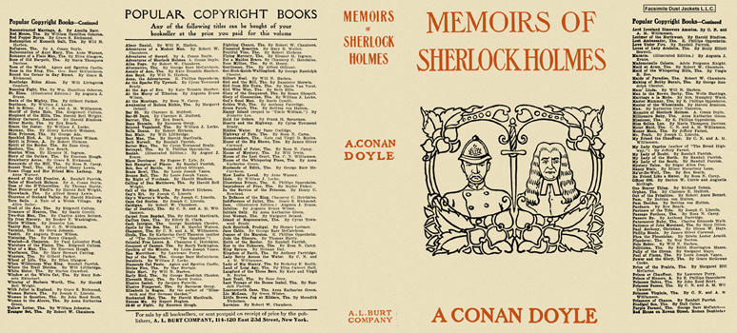

Doyle, Sir Arthur Conan
Memoirs of Sherlock Holmes
A. L. Burt Company (USA) (1894)

