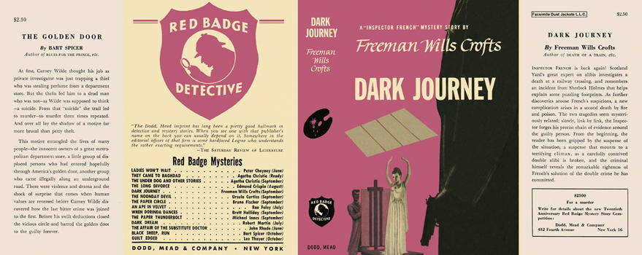

Crofts, Freeman Wills
Dark journey
Dodd, Mead & Company (USA) (1951) first printing

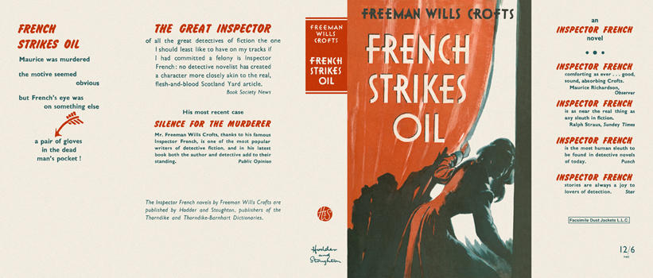

Crofts, Freeman Wills
French strikes oil
Hodder & Stoughton (UK) (1952) first printing

Суперобложки первых изданий романа

