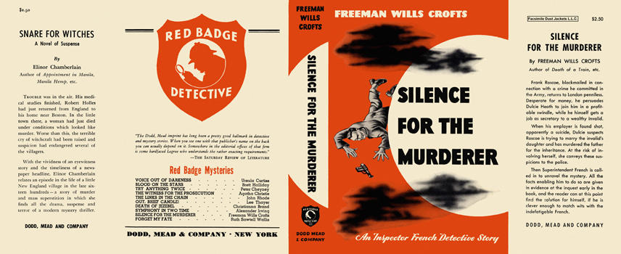

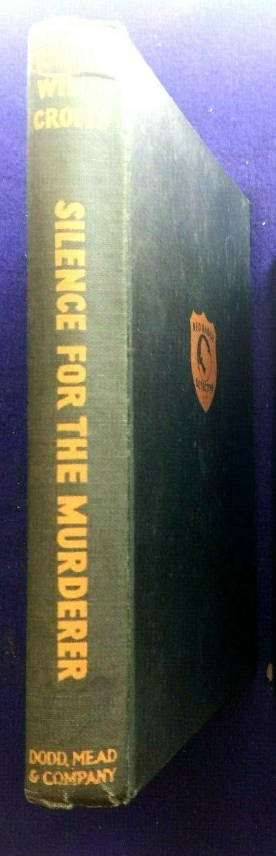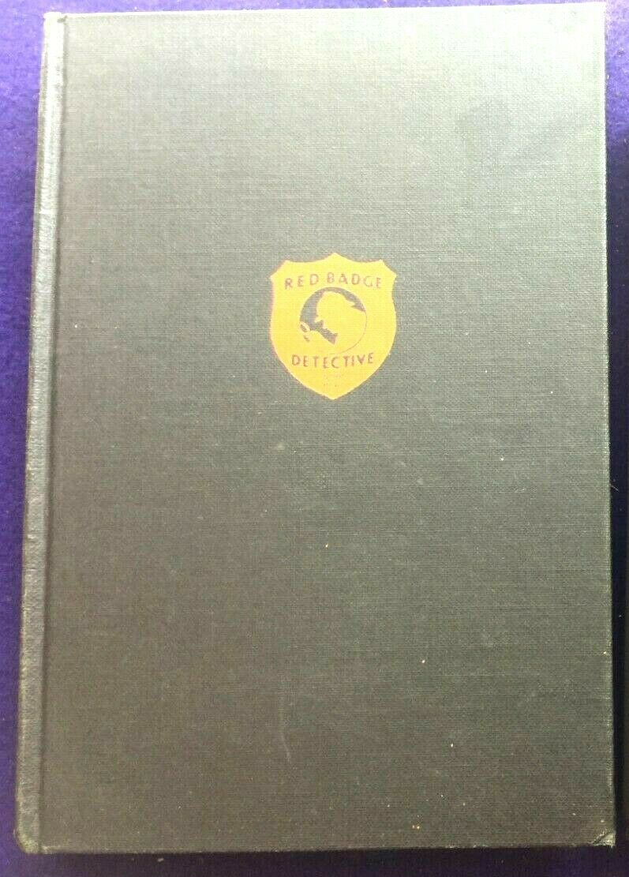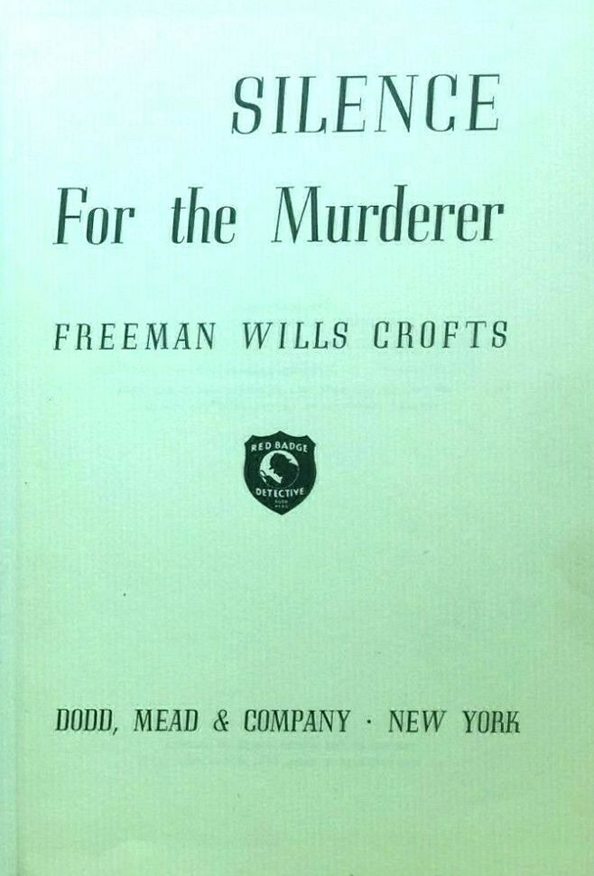

Crofts, Freeman Wills
Silence for the murderer
Dodd, Mead & Company (USA) (1948) first printing

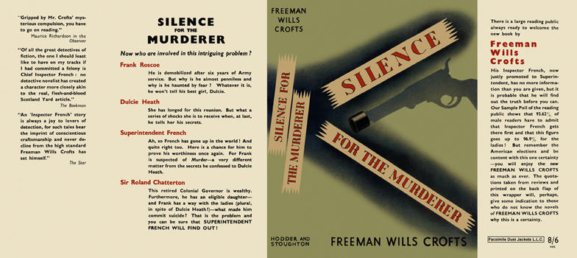

Crofts, Freeman Wills
Silence for the murderer
Hodder & Stoughton (UK) (1949) first printing

Суперобложки и внешний вид первых изданий романа

