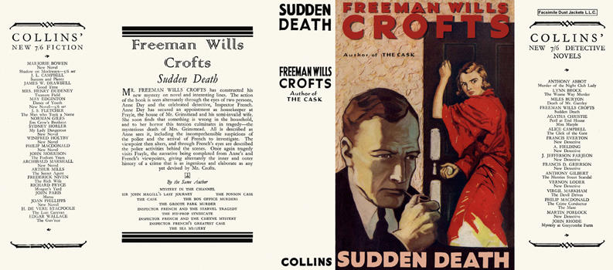

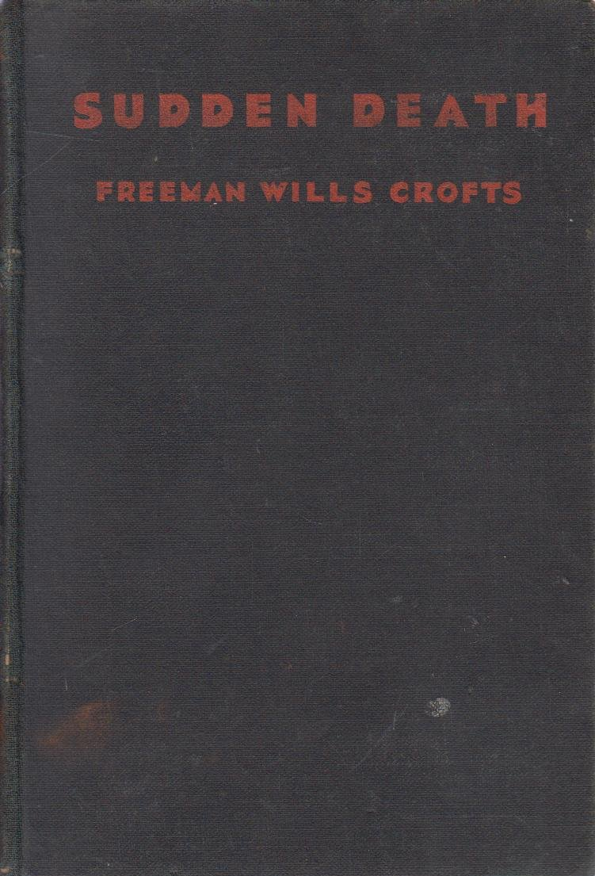

Crofts, Freeman Wills
Sudden death
Collins Detective Novel (UK) (1932) first printing (Colonial edition).

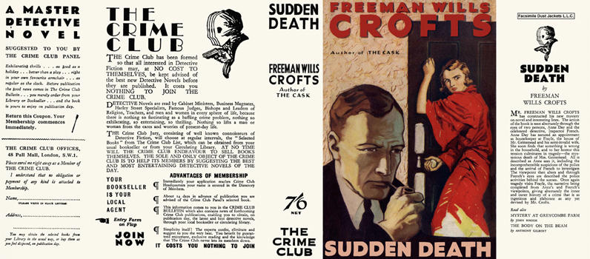

Crofts, Freeman Wills
Sudden death
Collins The Crime Club (UK) (1932) first printing

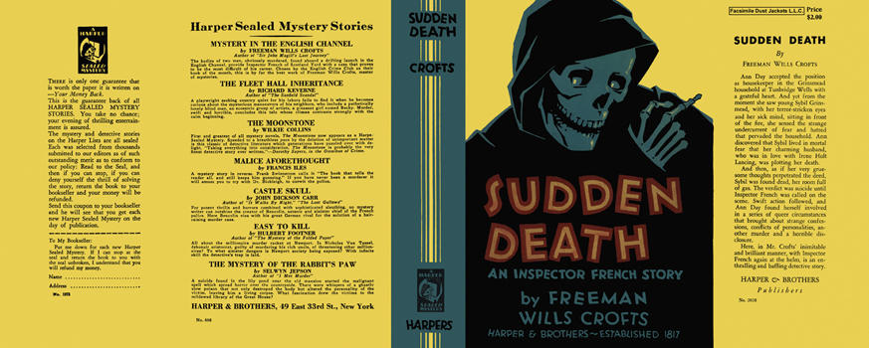

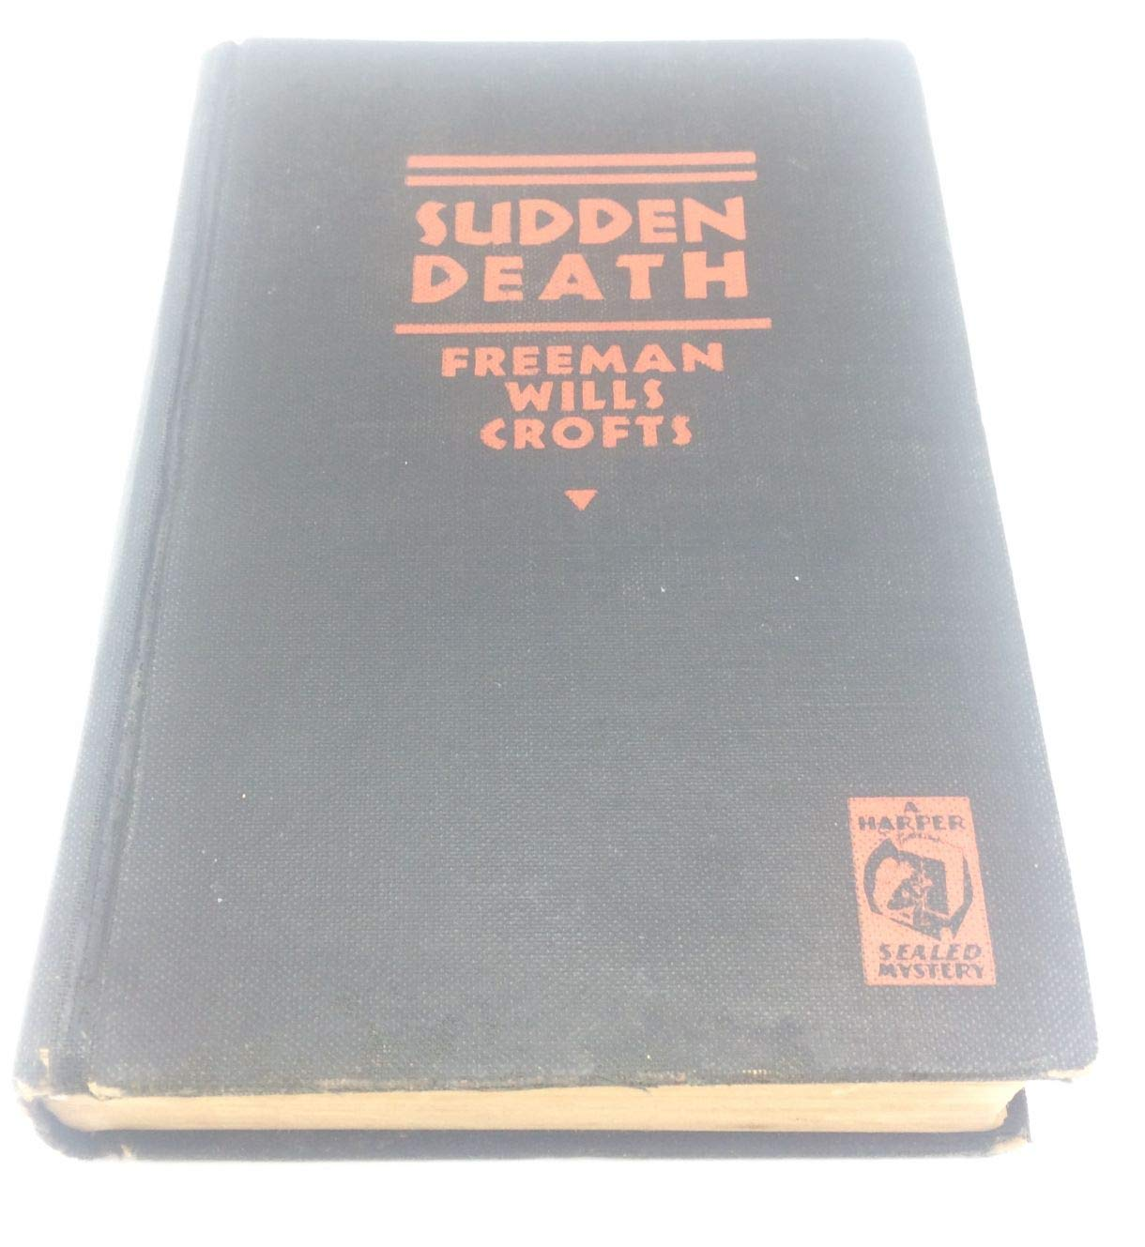

Crofts, Freeman Wills
Sudden death
Harper & Brothers (USA) (1932) first printing

Суперобложки и внешний вид первых изданий романа

