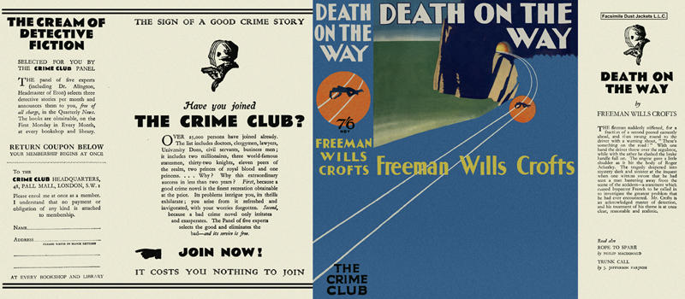

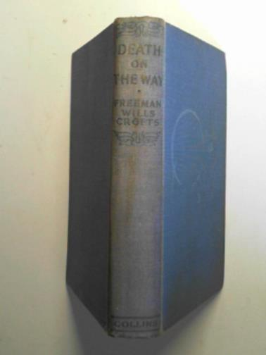

Crofts, Freeman Wills
Death on the way
Collins The Crime Club (UK) (1932)
first printing

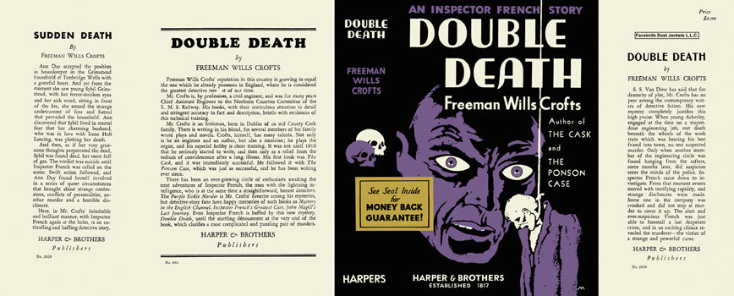

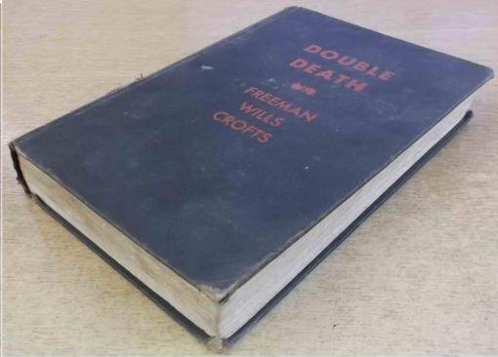

Crofts, Freeman Wills
Double death
Harper and Brothers (USA) (1932)
first printing

Суперобложки и внешний вид первых изданий романа

