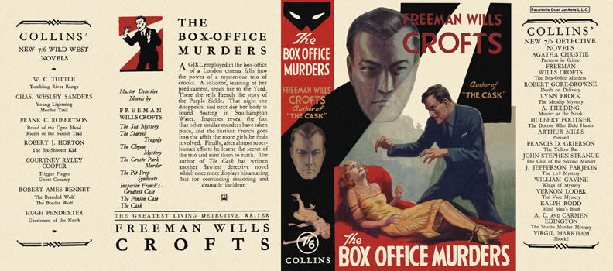

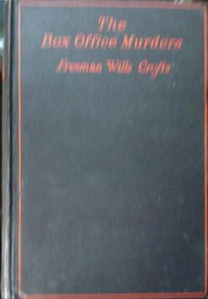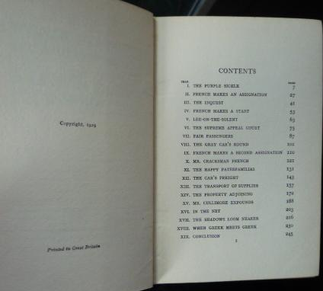

Crofts, Freeman Wills
The box office murders
Collins Detective Novel (UK) (1929) first printing.

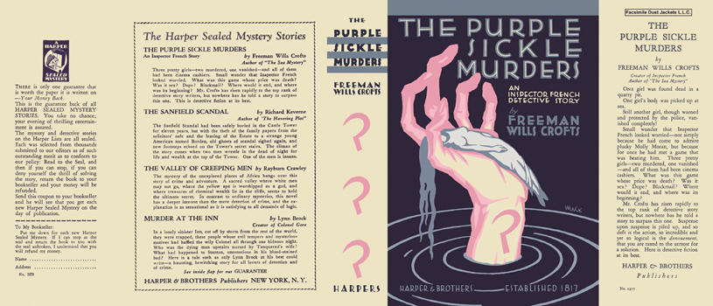

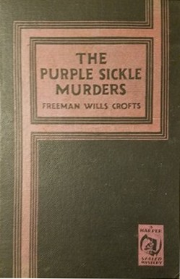

Crofts, Freeman Wills
The purple sickle murders
Harper & Brothers (USA) (1929) first printing.

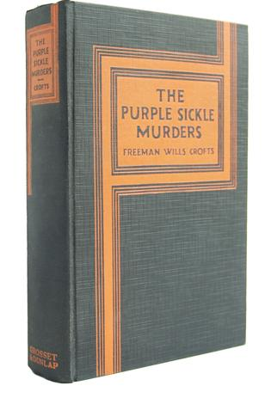

Crofts, Freeman Wills
The purple sickle murders
Grosset & Dunlap (USA) (1929) first printing.

Суперобложки и внешний вид первых изданий романа

