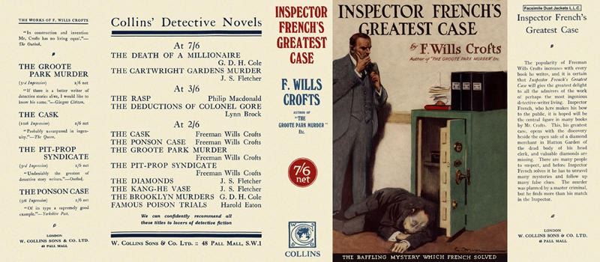

Crofts, Freeman Wills
Inspector French's greatest case
Collins Detective Novel (UK) (1924)
first printing

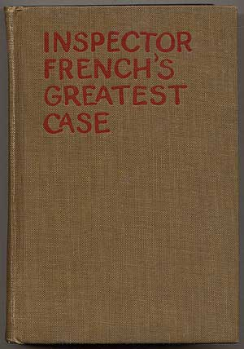

Crofts, Freeman Wills
Inspector French's greatest case
New York: Thomas Seltzer, 1925
first American edition

Суперобложка и внешний вид первых изданий романа

