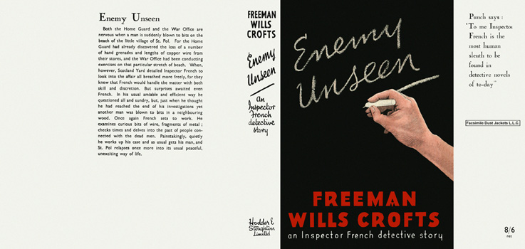

Crofts, Freeman Wills
Enemy unseen
Hodder & Stoughton (UK) (1945) first printing.

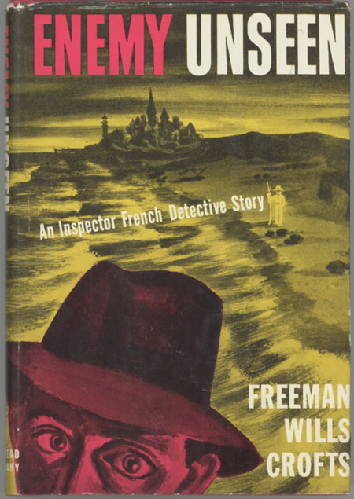

Crofts, Freeman Wills
Enemy unseen
Dodd, Mead & Company (US) (1945) first printing

Суперобложки первых изданий книги

