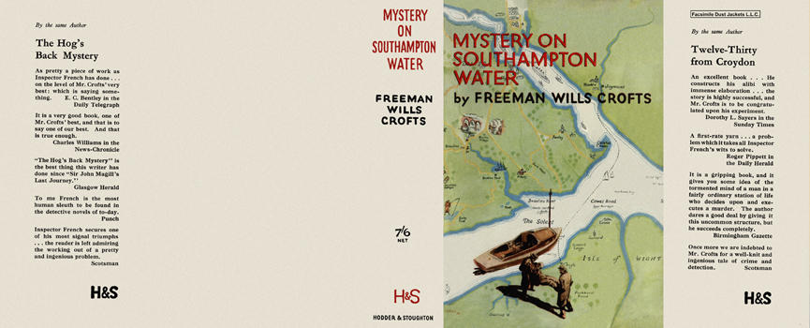

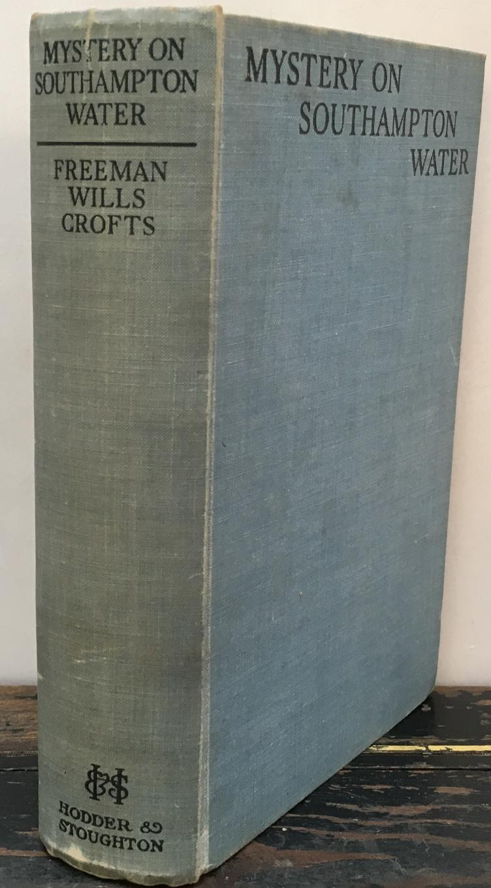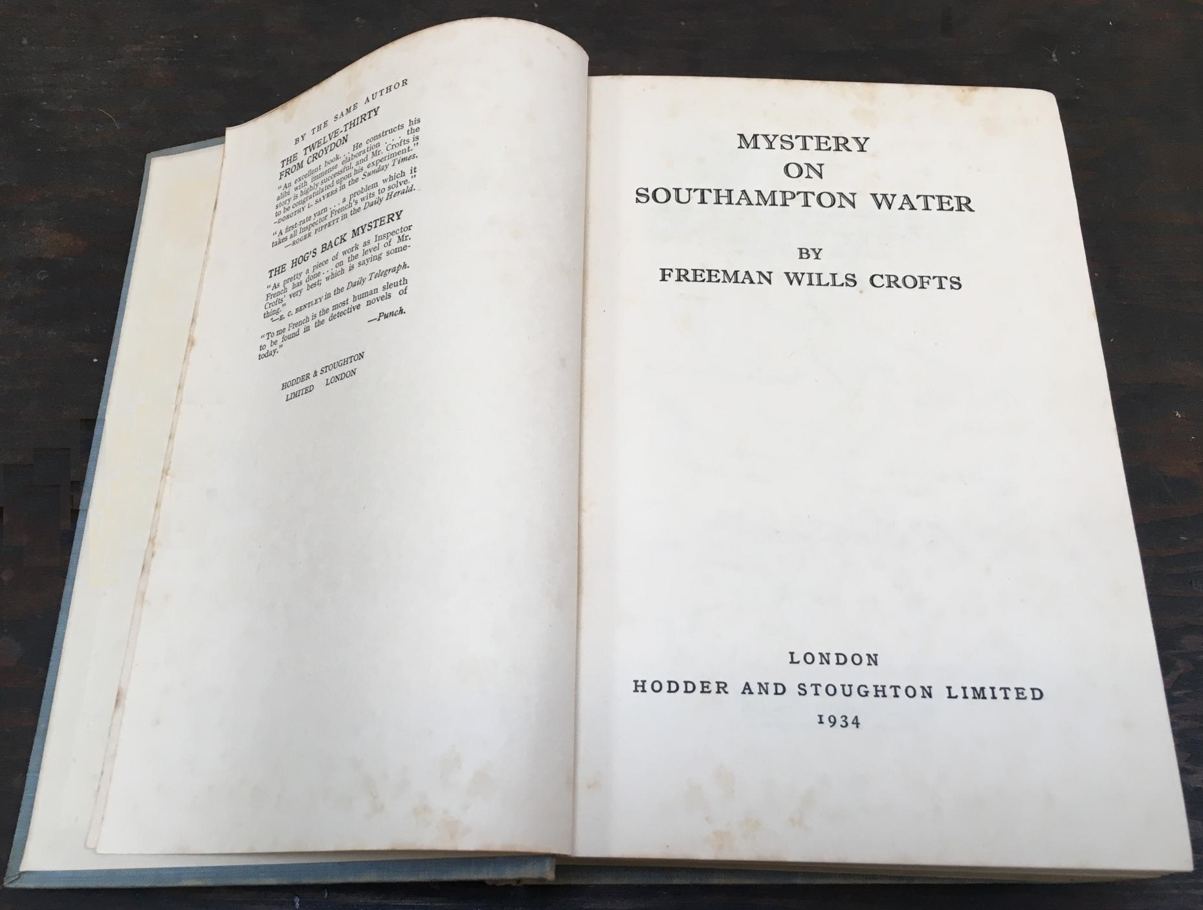

Crofts, Freeman Wills
Mystery on the Southampton water
Hodder and Stoughton (UK) (1934) first printing

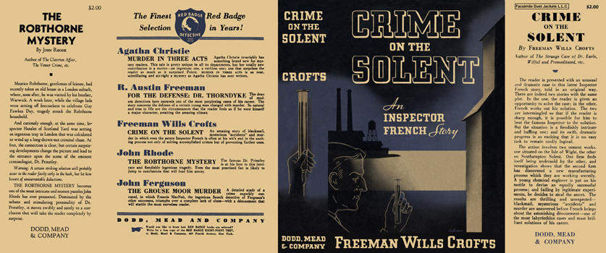

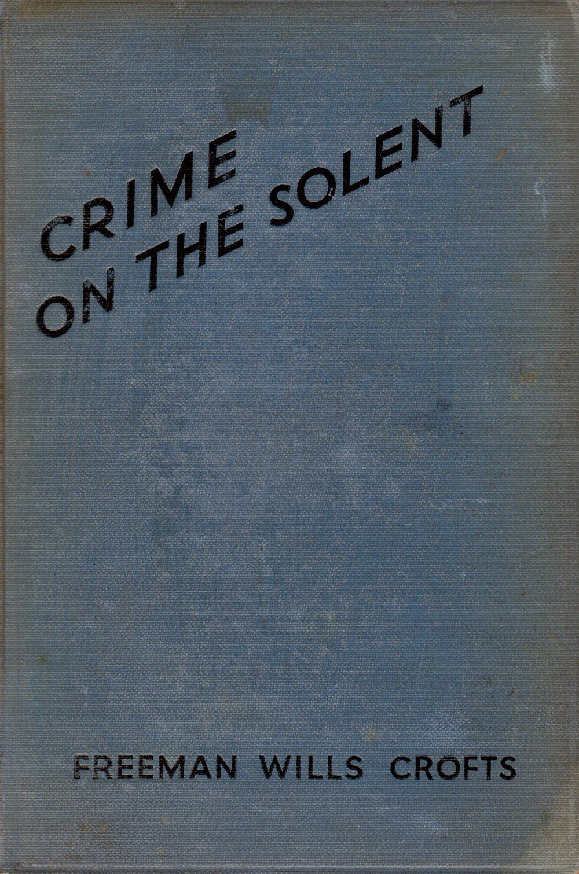

Crofts, Freeman Wills
Crime on the Solent
Dodd, Mead and Company (USA) (1934) first printing

Внешний вид первых изданий книги

