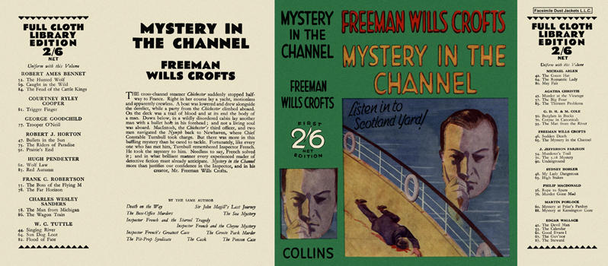

Mystery in the Channel
Crofts, Freeman Wills
Collins The Crime Club (UK) (1931) c1930s 2/6 reprint.

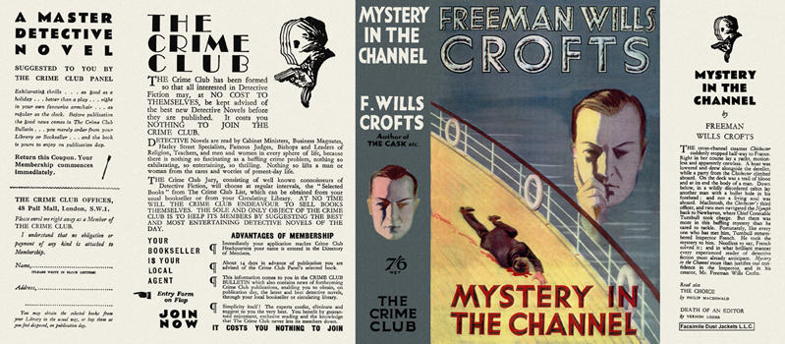

Mystery in the Channel
Crofts, Freeman Wills
Collins The Crime Club (UK) (1931) first printing

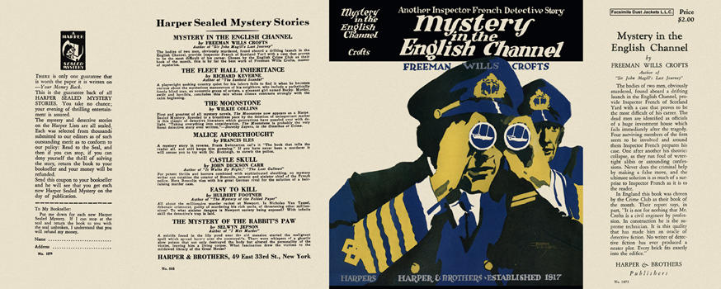

Mystery in the English Channel
Crofts, Freeman Wills
Harper & Brothers (USA) (1931) first printing

