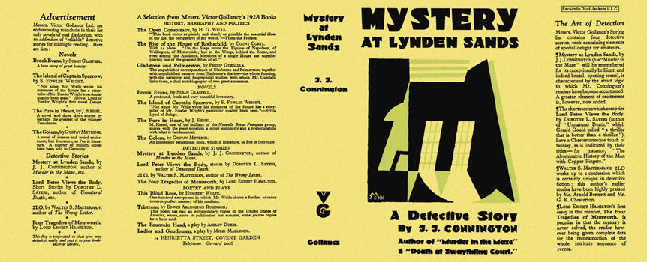

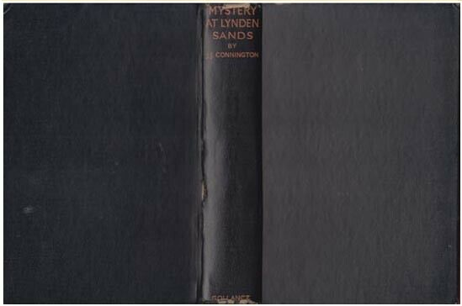

Connington, J. J.
Mystery at Lynden Sands
V. G. Gollancz (UK) (1928) first printing

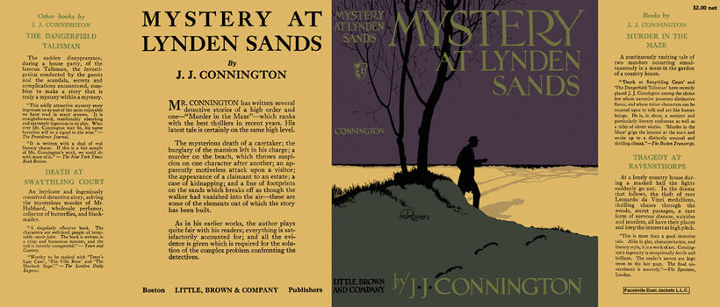

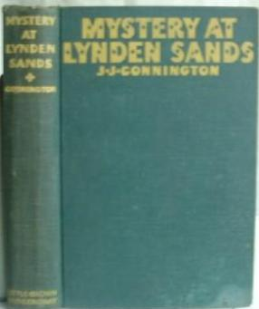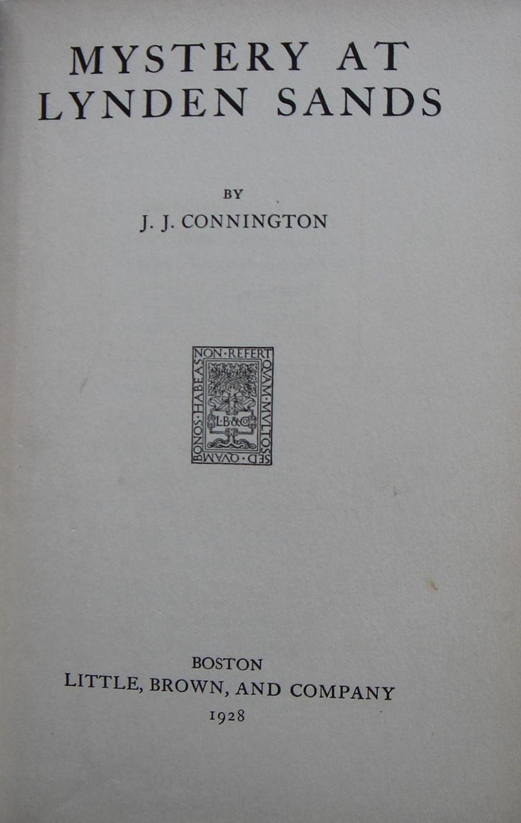

Connington, J. J.
Mystery at Lynden Sands
Little, Brown and Company (USA) (1928) first printing

Суперобложки и внешний вид первых изданий романа

