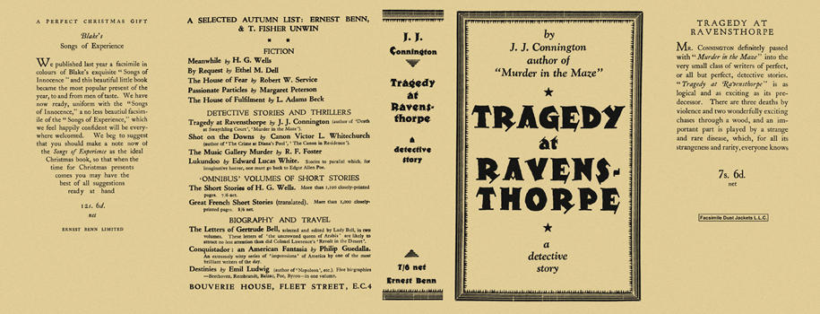

Connington, J. J.
Tragedy at Ravensthorpe
Ernest Benn Limited (UK) (1927) first printing

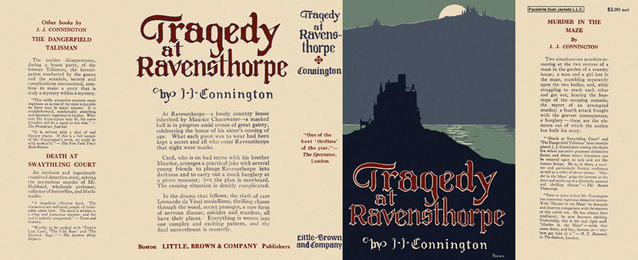

Connington, J. J.
Tragedy at Ravensthorpe
Little, Brown and Company (USA) (1928) first printing

Суперобложки первых изданий книги

