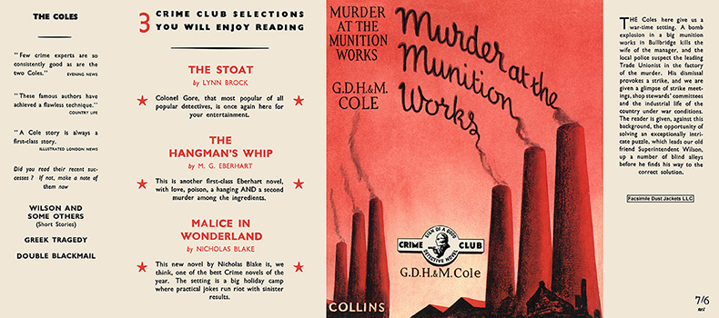

Cole, G. D. H. and Cole, Margaret
The murder at the munition works
Collins The Crime Club (UK) (1940) first printing

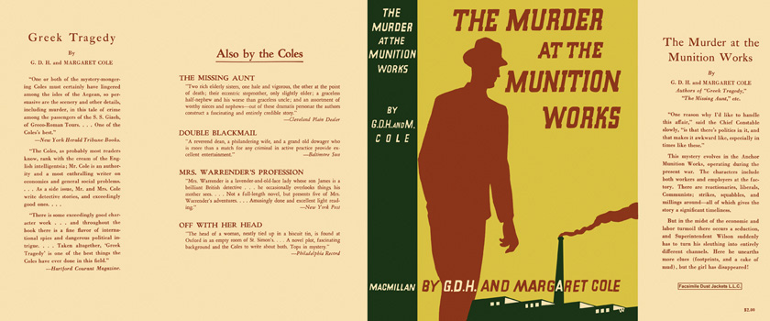

Cole, G. D. H. and Cole, Margaret
The murder at the munition works
The Macmillan Company (USA) (1940) first printing

Суперобложки первых изданий романа

