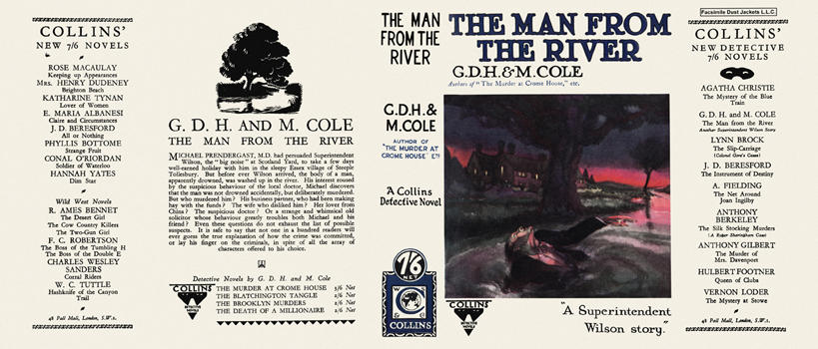

Cole, G. D. H. and Cole, Margaret
The man from the river
Collins Detective Novel (UK) (1928) first printing

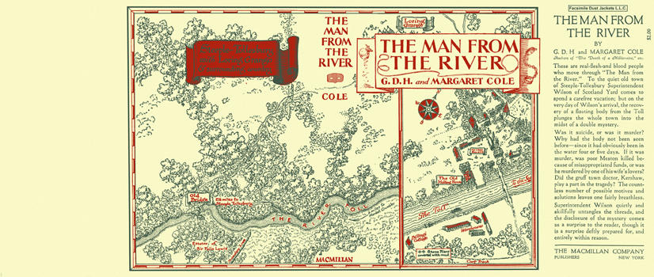

Cole, G. D. H. and Cole, Margaret
The man from the river
The Macmillan Company (USA) (1928) first printing

Суперобложки первых изданий романа

