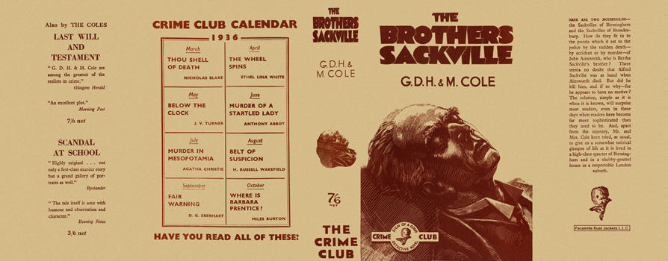

Cole, G. D. H. and Cole, Margaret
The brothers Sackville
Collins The Crime Club (UK) (1936) first printing.

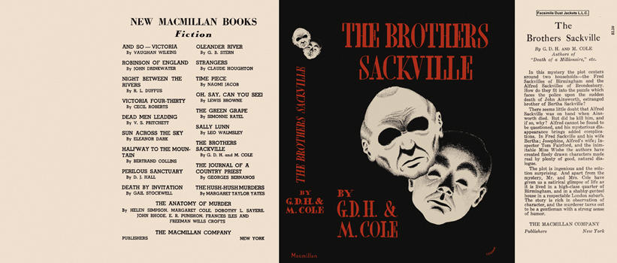

Cole, G. D. H. and Cole, Margaret
The brothers Sackville
The Macmillan Company (USA) (1937) first printing

Суперобложки первых изданий книги

