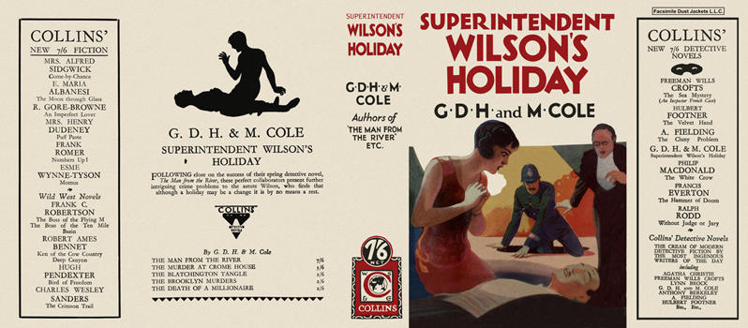

Superintendent Wilson's Holiday
Cole, G. D. H. and Cole, Margaret
Collins Detective Novel (UK) (1928) first printing.

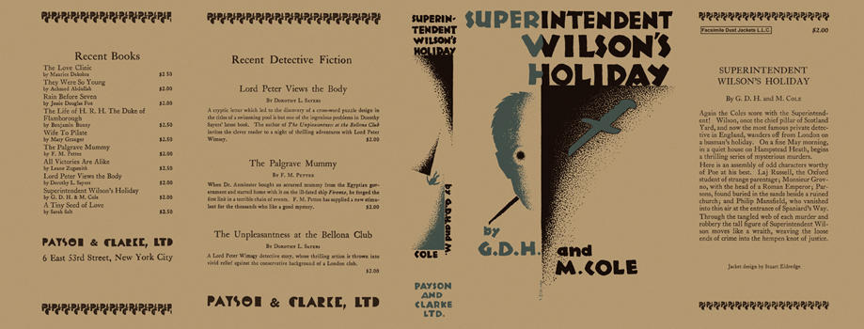

Superintendent Wilson's Holiday
Cole, G. D. H. and Cole, Margaret
Payson & Clarke Ltd. (USA) (1929) first printing.

