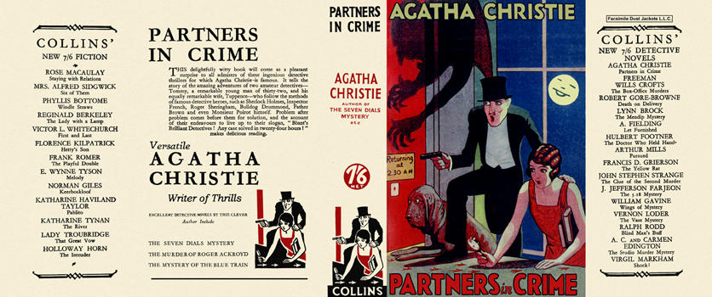

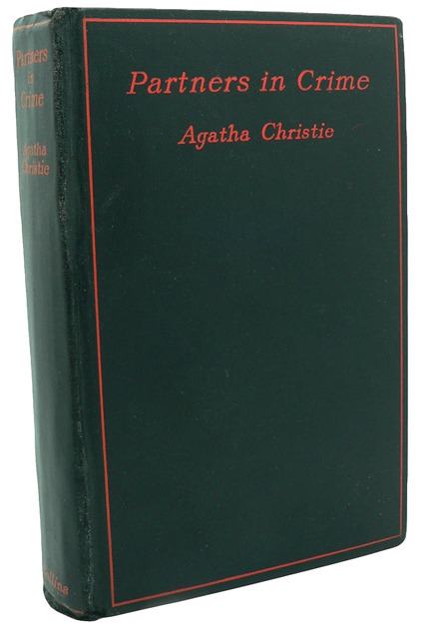

Christie, Agatha
Partners in crime
Collins Detective Novel (UK) (1929) first printing.

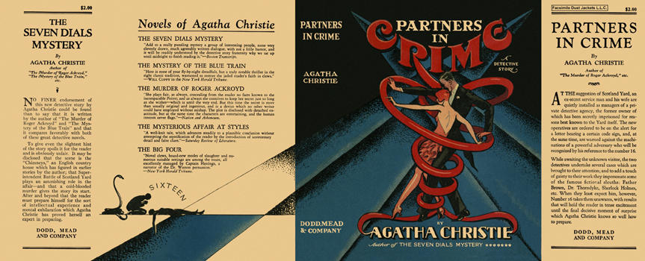

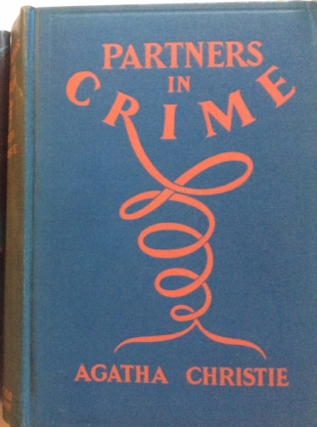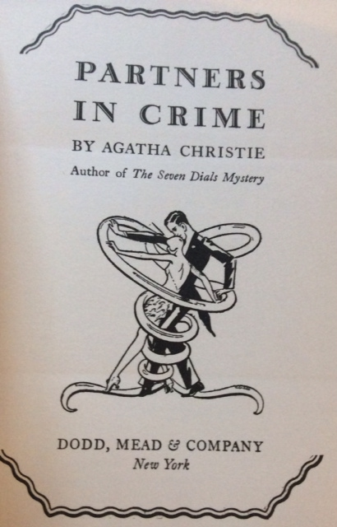

Christie, Agatha
Partners in crime
Dodd, Mead & Company (USA) (1929) first printing.

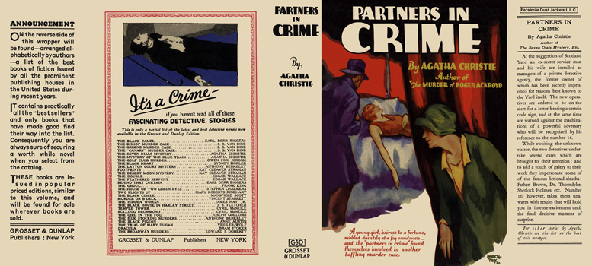

Christie, Agatha
Partners in crime
Grosset & Dunlap (USA) (1929) c1930 reprint.

Суперобложки и внешний вид первых изданий сборника

