Murder on the Orient express

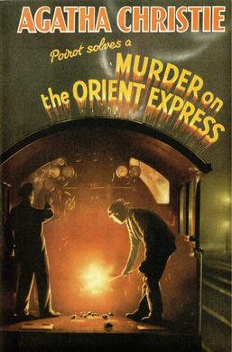

Dust-jacket illustration of the first UK edition
Collins Crime Club, 1934

