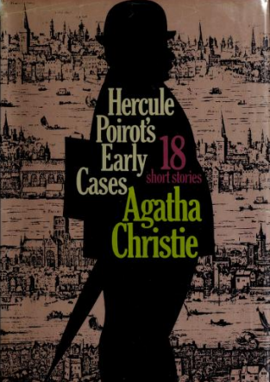

Agatha Christie
Hercule Poirot's early cases
N.Y.: Dodd, Mead and Company, 1974

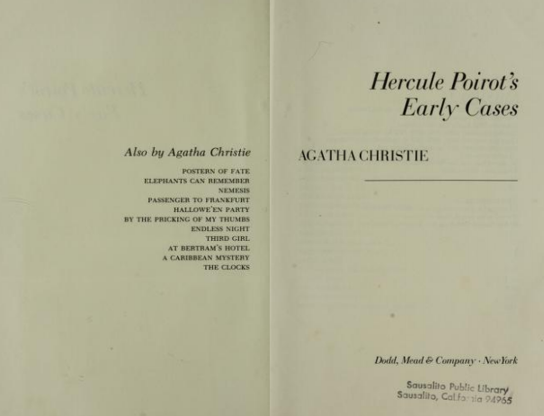

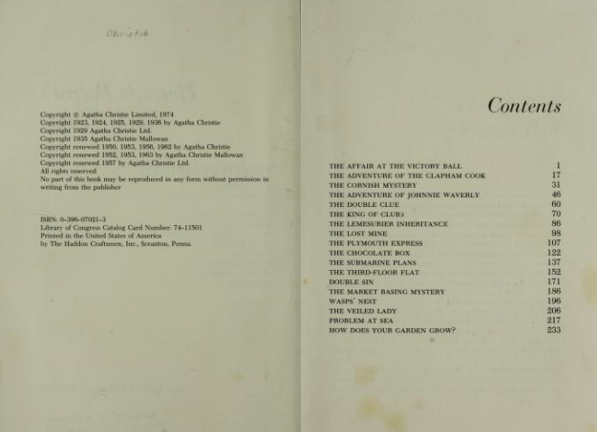

Agatha Christie

The lost mine

I laid down my bank book with a sigh.
'It is a curious thing’ I observed, 'but my overdraft never seems to grow any less.'
'And it perturbs you not? Me, if I had an overdraft, never should I close my eyes all night,' declared Poirot.
'You deal in comfortable balances, I suppose!' I retorted.
'Four hundred and forty-four pounds, four and fourpence,' said Poirot with some complacency. 'A neat figure, is it not?'
'It must be tact on the part of your bank manager. He is evidently acquainted with your passion for symmetrical details. What about investing, say, three hundred of it in the Porcupine oil-fields? Their prospectus, which is advertised in the papers today, says that they will pay one hundred per cent dividends next year.'
'Not for me,' said Poirot, shaking his head. 'I like not the sensational. For me the safe, the prudent investment— les rentes, the consols, the— how do you call it?— the conversion.'
'Have you never made a speculative investment?'
'No, mon ami,' replied Poirot severely. 'I have not. And the only shares I own which have not what you call the gilded edge are fourteen thousand shares in the Burma Mines Ltd.'
Poirot paused with an air of waiting to be encouraged to go on.
'Yes?' I prompted.
'And for them I paid no cash— no, they were the reward of the exercise of my little grey cells. You would like to hear the story? Yes?'
'Of course I would.'
'These mines are situated in the interior of Burma about two hundred miles inland from Rangoon. They were discovered by the Chinese in the fifteenth century and worked down to the time of the Mohammedan Rebellion, being finally abandoned in the year 1868. The Chinese extracted the rich lead-silver ore from the upper part of the ore body, smelting it for the silver alone, and leaving large quantities of rich lead-bearing slag. This, of course, was soon discovered when prospecting work was carried out in Burma, but owing to the fact that the old workings had become full of loose filling and water, all attempts to find the source of the ore proved fruitless. Many parties were sent out by syndicates, and they dug over a large area, but this rich prize still eluded them. But a representative of one of the syndicates got on the track of a Chinese family who were supposed to have still kept a record of the situation of the mine. The present head of the family was one Wu Ling.'
'What a fascinating page of commercial romance!' I exclaimed.
'Is it not? Ah, mon ami, one can have romance without golden-haired girls of matchless beauty — no, I am wrong; it is auburn hair that so excites you always. You remember —'
'Go on with the story,' I said hastily.
'Eh bien, my friend, this Wu Ling was approached. He was an estimable merchant, much respected in the province where he lived. He admitted at once that he owned the documents in question, and was perfectly prepared to negotiate for this sale, but he objected to dealing with anyone other than principals. Finally it was arranged that he should journey to England and meet the directors of an important company.'
'Wu Ling made the journey to England in the SS Assunta, and the Assunta docked at Southampton on a cold, foggy morning in November. One of the directors, Mr Pearson, went down to Southampton to meet the boat, but owing to the fog, the train down was very much delayed, and by the time he arrived, Wu Ling had disembarked and left by special train for London. Mr Pearson returned to town somewhat annoyed, as he had no idea where the Chinaman proposed to stay. Later in the day, however, the offices of the company were rung up on the telephone. Wu Ling was staying at the Russell Square Hotel. He was feeling somewhat unwell after the voyage, but declared himself perfectly able to attend the board meeting on the following day.'
'The meeting of the board took place at eleven o'clock. When half past eleven came, and Wu Ling had not put in an appearance, the secretary rang up the Russell Hotel. In answer to his inquiries, he was told that the Chinaman had gone out with a friend about half past ten. It seemed clear that he had started out with the intention of coming to the meeting, but the morning wore away, and he did not appear. It was, of course, possible that he had lost his way, being unacquainted with London, but at a late hour that night he had not returned to the hotel. Thoroughly alarmed now, Mr Pearson put matters in the hands of the police. On the following day, there was still no trace of the missing man, but towards evening of the day after that again, a body was found in the Thames which proved to be that of the ill-fated Chinaman. Neither on the body, nor in the luggage at the hotel, was there any trace of the papers relating to the mine.'
'At this juncture, mon ami, I was brought into the affair. Mr Pearson called upon me.
While profoundly shocked by the death of Wu Ling, his chief anxiety was to recover the papers which were the object of the Chinaman's visit to England. The main anxiety of the police, of course, would be to track down the murderer— the recovery of the papers would be a secondary consideration. What he wanted me to do was to co-operate with the police while acting in the interests of the company.'
'I consented readily enough. It was clear that there were two fields of search open to me. On the one hand, I might look among the employees of the company who knew of the Chinaman's coming; on the other, among the passengers on the boat who might have been acquainted with his mission. I started with the second, as being a narrower field of search. In this I coincided with Inspector Miller, who was in charge of the case— a man altogether different from our friend Japp, conceited, ill-mannered and quite insufferable.
Together we interviewed the officers of the ship. They had little to tell us. Wu Ling had kept much to himself on the voyage. He had been intimate with but two of the other passengers— one a broken-down European named Dyer who appeared to bear a somewhat unsavoury reputation, the other a young bank clerk named Charles Lester, who was returning from Hong Kong. We were lucky enough to obtain snapshots of both these men. At the moment there seemed little doubt that if either of the two was implicated, Dyer was the man. He was known to be mixed up with a gang of Chinese crooks, and was altogether a most likely suspect.'
'Our next step was to visit the Russell Square Hotel. Shown a snapshot of Wu Ling, they recognized him at once. We then showed them the snapshot of Dyer, but to our disappointment, the hall porter declared positively that that was not the man who had come to the hotel on the fatal morning. Almost as an afterthought, I produced the photograph of Lester, and to my surprise the man at once recognized it.'
'"Yes, sir," he asserted, "that's the gentleman who came in at half past ten and asked for Mr Wu Ling, and afterwards went out with him.'"
'The affair was progressing. Our next move was to interview Mr Charles Lester. He met us with the utmost frankness, was desolated to hear of the Chinaman's untimely death, and put himself at our disposal in every way. His story was as follows: By arrangement with Wu Ling, he called for him at the hotel at ten-thirty. Wu Ling, however, did not appear.
Instead, his servant came, explained that his master had had to go out, and offered to conduct the young man to where his master now was. Suspecting nothing, Lester agreed, and the Chinaman procured a taxi. They drove for some time in the direction of the docks. Suddenly becoming mistrustful, Lester stopped the taxi and got out, disregarding the servant's protests. That, he assured us, was all he knew.'
'Apparently satisfied, we thanked him and took our leave. His story was soon proved to be a somewhat inaccurate one. To begin with, Wu Ling had had no servant with him, either on the boat or at the hotel. In the second place, the taxi driver who had driven the two men on that morning came forward. Far from Lester's having left the taxi en route, he and the Chinese gentleman had driven to a certain unsavoury dwelling-place in Limehouse, right in the heart of Chinatown. The place in question was more or less well known as an opium-den of the lowest description. The two gentlemen had gone in— about an hour later the English gentleman, whom he identified from the photograph, came out alone. He looked very pale and ill, and directed the taxi-man to take him to the nearest underground station.'
'Inquiries were made about Charles Lester's standing, and it was found that, though bearing an excellent character, he was heavily in debt, and had a secret passion for gambling. Dyer, of course, was not lost sight of. It seemed just faintly possible that he might have impersonated the other man, but that idea was proved utterly groundless. His alibi for the whole of the day in question was absolutely unimpeachable. Of course, the proprietor of the opium-den denied everything with Oriental stolidity. He had never seen Charles Lester. No two gentlemen had been to the place that morning. In any case, the police were wrong: no opium was ever smoked there.'
'His denials, however well meant, did little to help Charles Lester. He was arrested for the murder of Wu Ling. A search of his effects was made, but no papers relating to the mine were discovered. The proprietor of the opium-den was also taken into custody, but a cursory raid of his premises yielded nothing. Not even a stick of opium rewarded the zeal of the police.'
'In the meantime my friend Mr Pearson was in a great state of agitation. He strode up and down my room, uttering great lamentations.'
"'But you must have some ideas, M. Poirot!" he kept urging. "Surely you must have some ideas!"'
"'Certainly I have ideas," I replied cautiously. "That is the trouble— one has too many; therefore they all lead in different directions.'"
"'For instance?" he suggested.
"'For instance— the taxi-driver. We have only his word for it that he drove the two men to that house. That is one idea. Then— was it really that house they went to? Supposing that they left the taxi there, passed through the house and out by another entrance and went elsewhere?"'
'Mr Pearson seemed struck by that.'
"'But you do nothing but sit and think? Can't we do something?"'
'He was of an impatient temperament, you comprehend.'
'"Monsieur," I said with dignity, "It is not for Hercule Poirot to run up and down the evil-smelling streets of Limehouse like a little dog of no breeding. Be calm. My agents are at work.'"
'On the following day I had news for him. The two men had indeed passed through the house in question, but their real objective was a small eating-house close to the river. They were seen to pass in there, and Lester came out alone.'
'And then, figure to yourself, Hastings, an idea of the most unreasonable seized this Mr Pearson! Nothing would suit him but that we should go ourselves to this eating-house and make investigations. I argued and prayed, but he would not listen. He talked of disguising himself — he even suggested that I — I should — I hesitate to say it — should shave off my moustache! Yes, rien que ga ! I pointed out to him that that was an idea ridiculous and absurd. One destroys not a thing of beauty wantonly. Besides, shall not a Belgian gentleman with a moustache desire to see life and smoke opium just as readily as one without a moustache?'
'Eh bien, he gave in on that, but he still insisted on his project. He turned up that evening — Mon dieu, what a figure! He wore what he called the "pea-jacket", his chin, it was dirty and unshaved; he had a scarf of the vilest that offended the nose. And figure to yourself, he was enjoying himself! Truly, the English are mad! He made some changes in my own appearance. I permitted it. Can one argue with a maniac? We started out — after all, could I let him go alone, a child dressed up to act the charades?'
'Of course you couldn't,' I replied.
'To continue — we arrived. Mr Pearson talked English of the strangest. He represented himself to be a man of the sea. He talked of "lubbers" and "focselles" and I know not what. It was a low little room with many Chinese in it. We ate of peculiar dishes. Ah, Dieu, mon estomac!' Poirot clasped that portion of his anatomy before continuing. 'Then there came to us the proprietor, a Chinaman with a face of evil smiles.'
'"You gentlemen no likee food here," he said. "You come for what you likee better. Piecee pipe, eh?"'
'Mr Pearson, he gave me the great kick under the table. (He had on the boots of the sea too!) And he said: "I don't mind if I do, John. Lead ahead.'"
'The Chinaman smiled, and he took us through a door and to a cellar and through a trapdoor, and down some steps and up again into a room all full of divans and cushions of the most comfortable. We lay down and a Chinese boy took off our boots. It was the best moment of the evening. Then they brought us the opium-pipes and cooked the opium-pills, and we pretended to smoke and then to sleep and dream. But when we were alone, Mr Pearson called softly to me, and immediately he began crawling along the floor. We went into another room where other people were asleep, and so on, until we heard two men talking. We stayed behind a curtain and listened. They were speaking of Wu Ling.'
"'What about the papers?" said one.
"'Mr Lester, he takee those," answered the other, who was a Chinaman. "He say, puttee them allee in safee place — where pleeceman no lookee.'"
"'Ah, but he's nabbed," said the first one.
"'He gettee free. Pleeceman not sure he done it.'"
'There was more of the same kind of thing, then apparently the two men were coming our way, and we scuttled back to our beds.'
"'We'd better get out of here," said Pearson, after a few minutes had elapsed. "This place isn't healthy.'"
"'You are right, monsieur," I agreed. "We have played the farce long enough.'"
'We succeeded in getting away, all right, paying handsomely for our smoke. Once clear of Limehouse, Pearson drew a long breath.'
"'I'm glad to get out of that," he said. "But it's something to be sure.'"
'"It is indeed," I agreed. "And I fancy that we shall not have much difficulty in finding what we want — after this evening's masquerade.'"
'And there was no difficulty whatsoever,' finished Poirot suddenly.
This abrupt ending seemed so extraordinary that I stared at him.
'But — but where were they?' I asked.
'In his pocket — tout simplement.'
'But in whose pocket?'
'Mr Pearson's, parbleu!' Then, observing my look of bewilderment, he continued gently: 'You do not yet see it? Mr Pearson, like Charles Lester, was in debt. Mr Pearson, like Charles Lester, was fond of gambling. And he conceived the idea of stealing the papers from the Chinaman. He met him all right at Southampton, came up to London with him, and took him straight to Limehouse. It was foggy that day; the Chinaman would not notice where he was going. I fancy Mr Pearson smoked the opium fairly often down there and had some peculiar friends in consequence. I do not think he meant murder. His idea was that one of the Chinamen should impersonate Wu Ling and receive the money for the sale of the document. So far, so good! But, to the Oriental mind, it was infinitely simpler to kill Wu Ling and throw his body into the river, and Pearson's Chinese accomplices followed their own methods without consulting him. Imagine, then, what you would call the "funk bleu" of M. Pearson. Someone may have seen him in the train with Wu Ling— murder is a very different thing from simple abduction.'
'His salvation lies with the Chinaman who is personating Wu Ling at the Russell Square Hotel. If only the body is not discovered too soon! Probably Wu Ling had told him of the arrangement between him and Charles Lester whereby the latter was to call for him at the hotel. Pearson sees there an excellent way of diverting suspicion from himself. Charles Lester shall be the last person to be seen in company with Wu Ling. The impersonator has orders to represent himself to Lester as the servant of Wu Ling, and to bring him as speedily as possible to Limehouse. There, very likely, he was offered a drink. The drink would be suitably drugged, and when Lester emerged an hour later, he would have a very hazy impression of what had happened. So much was this the case, that as soon as Lester learned of Wu Ling's death, he loses his nerve, and denies that he ever reached Limehouse.'
'By that, of course, he plays right into Pearson's hands. But is Pearson content? No — my manner disquiets him, and he determines to complete the case against Lester. So he arranges an elaborate masquerade. Me, I am to be gulled completely. Did I not say just now that he was as a child acting the charades? Eh bien, I play my part. He goes home rejoicing. But in the morning, Inspector Miller arrives on his doorstep. The papers are found on him; the game is up. Bitterly he regrets permitting himself to play the farce with Hercule Poirot! There was only one real difficulty in the affair.'
'What was that?' I demanded curiously.
'Convincing Inspector Miller! What an animal, that! Both obstinate and imbecile. And in the end he took all the credit!'
'Too bad,' I cried.
'Ah, well, I had my compensations. The other directors of the Burma Mines Ltd awarded me fourteen thousand shares as a small recompense for my services. Not so bad, eh? But when investing money, keep, I beg of you, Hastings, strictly to the conservative. The things you read in the paper, they may not be true. The directors of the Porcupine — they may be so many Mr Pearsons!'

