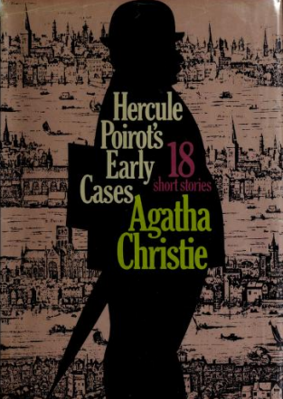

Agatha Christie
Hercule Poirot's early cases
N.Y.: Dodd, Mead and Company, 1974

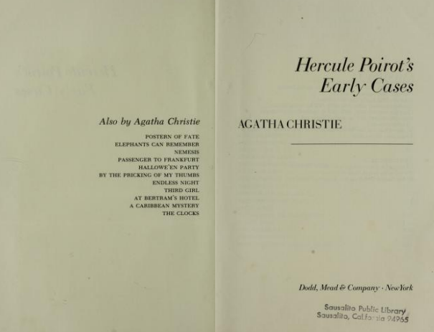

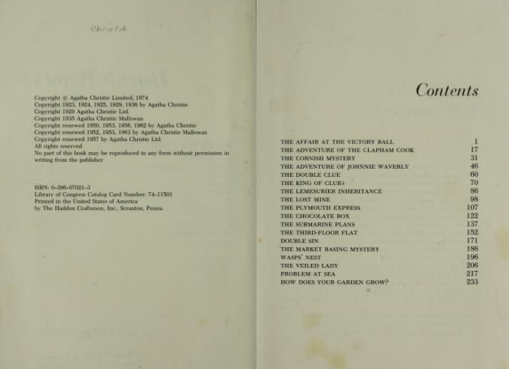

Agatha Christie

The veiled lady

I

I had noticed that for some time Poirot had been growing increasingly dissatisfied and restless. We had had no interesting cases of late, nothing on which my little friend could exercise his keen wits and remarkable powers of deduction. This morning he flung down the newspaper with an impatient 'Tchah!' — a favourite exclamation of his which sounded exactly like a cat sneezing.
'They fear me, Hastings; the criminals of your England they fear me! When the cat is there, the little mice, they come no more to the cheese!'
'I don't suppose the greater part of them even know of your existence,' I said, laughing.
Poirot looked at me reproachfully. He always imagines that the whole world is thinking and talking of Hercule Poirot. He had certainly made a name for himself in London, but I could hardly believe that his existence struck terror into the criminal world.
'What about that daylight robbery of jewels in Bond Street the other day?' I asked.
'A neat coup,' said Poirot approvingly, 'though not in my line. Pas de finesse, seulement de I'audace! A man with a loaded cane smashes the plate-glass window of a jeweller's shop and grabs a number of precious stones. Worthy citizens immediately seize him; a policeman arrives. He is caught red-handed with the jewels on him. He is marched off to the police, and then it is discovered that the stones are paste. He has passed the real ones to a confederate — one of the aforementioned worthy citizens. He will go to prison — true; but when he comes out, there will be a nice little fortune awaiting him. Yes, not badly imagined. But I could do better than that. Sometimes, Hastings, I regret that I am of such a moral disposition. To work against the law, it would be pleasing, for a change.'
'Cheer up, Poirot; you know you are unique in your own line.'
'But what is there on hand in my own line?'
I picked up the paper.
'Here's an Englishman mysteriously done to death in Holland,' I said.
'They always say that — and later they find that he ate the tinned fish and that his death is perfectly natural.'
'Well, if you're determined to grouse!'
'Tiensl' said Poirot, who had strolled across to the window. 'Here in the street is what they call in novels a "heavily veiled lady". She mounts the steps; she rings the bell — she comes to consult us. Here is a possibility of something interesting. When one is as young and pretty as that one, one does not veil the face except for a big affair.'
A minute later our visitor was ushered in. As Poirot had said, she was indeed heavily veiled. It was impossible to distinguish her features until she raised her veil of black Spanish lace. Then I saw that Poirot's intuition had been right; the lady was extremely pretty, with fair hair and blue eyes. From the costly simplicity of her attire, I deduced at once that she belonged to the upper strata of society.
'Monsieur Poirot,' said the lady in a soft, musical voice, 'I am in great trouble. I can hardly believe that you can help me, but I have heard such wonderful things of you that I come literally as the last hope to beg you to do the impossible.'
'The impossible, it pleases me always,' said Poirot. 'Continue, I beg of you, mademoiselle.'
Our fair guest hesitated.
'But you must be frank,' added Poirot. 'You must not leave me in the dark on any point.'
'I will trust you,' said the girl suddenly. 'You have heard of Lady Millicent Castle Vaughan?'
I looked up with keen interest. The announcement of Lady Millicent's engagement to the young Duke of Southshire had appeared a few days previously. She was, I knew, the fifth daughter of an impecunious Irish peer, and the Duke of Southshire was one of the best matches in England.
'I am Lady Millicent,' continued the girl. 'You may have read of my engagement. I should be one of the happiest girls alive; but oh, M. Poirot, I am in terrible trouble! There is a man, a horrible man — his name is Lavington; and he — I hardly know how to tell you. There was a letter I wrote — I was only sixteen at the time; and he — he — '
'A letter that you wrote to this Mr Lavington?'
'Oh no — not to him! To a young soldier — I was very fond of him — he was killed in the war.'
I understand,' said Poirot kindly.
'It was a foolish letter, an indiscreet letter, but indeed, M. Poirot, nothing more. But there are phrases in it which — which might bear a different interpretation.'
'I see,' said Poirot. 'And this letter has come into the possession of Mr Lavington?'
'Yes, and he threatens, unless I pay him an enormous sum of money, a sum that is quite impossible for me to raise, to send it to the Duke.'
'The dirty swine!' I ejaculated. 'I beg your pardon, Lady Millicent.'
'Would it not be wiser to confess all to your future husband?'
'I dare not, M. Poirot. The Duke is a rather peculiar character, jealous and suspicious and prone to believe the worst. I might as well break off my engagement at once.'
'Dear, dear,' said Poirot with an expressive grimace. 'And what do you want me to do, milady?'
'I thought perhaps that I might ask Mr Lavington to call upon you. I would tell him that you were empowered by me to discuss the matter. Perhaps you could reduce his demands.'
'What sum does he mention?'
'Twenty thousand pounds — an impossibility. I doubt if I could raise a thousand, even.'
'You might perhaps borrow the money on the prospect of your approaching marriage — but I doubt if you could get hold of half that sum. Besides — eh bien, it is repungnant to me that you should pay! No, the ingenuity of Hercule Poirot shall defeat your enemies! Send me this Mr Lavington. Is he likely to bring the letter with him?'
The girl shook her head.
'I do not think so. He is very cautious.'
'I suppose there is no doubt that he really has it?'
'He showed it to me when I went to his house.'
'You went to his house? That was very imprudent, milady.'
'Was it? I was so desperate. I hoped my entreaties might move him.'
'Oh, lala! The Lavingtons of this world are not moved by entreaties! He would welcome them as showing how much importance you attached to the document. Where does he live, this fine gentleman?'
'At Buona Vista, Wimbledon. I went there after dark —' Poirot groaned. 'I declared that I would inform the police in the end, but he only laughed in a horrid, sneering manner. "By all means, my dear Lady Millicent, do so if you wish," he said.'
'Yes, it is hardly an affair for the police,' murmured Poirot.
"'But I think you will be wiser than that," he continued. "See, here is your letter — in this little Chinese puzzle box!" He held it so that I could see. I tried to snatch at it, but he was too quick for me. With a horrid smile he folded it up and replaced it in the little wooden box. "It will be quite safe here, I assure you," he said, "and the box itself lives in such a clever place that you would never find it." My eyes turned to the small wall-safe, and he shook his head and laughed. "I have a better safe than that," he said. Oh, he was odious! M. Poirot, do you think that you can help me?'
'Have faith in Papa Poirot. I will find a way.'
These reassurances were all very well, I thought, as Poirot gallantly ushered his fair client down the stairs, but it seemed to me that we had a tough nut to crack. I said as much to Poirot when he returned. He nodded ruefully.
'Yes — the solution does not leap to the eye. He has the whip hand, this M. Lavington. For the moment I do not see how we are to circumvent him.'

II

Mr Lavington duly called upon us that afternoon. Lady Millicent had spoken truly when she described him as an odious man. I felt a positive tingling in the end of my boot, so keen was I to kick him down the stairs. He was blustering and overbearing in manner, laughed Poirot's gentle suggestions to scorn, and generally showed himself as master of the situation. I could not help feeling that Poirot was hardly appearing at his best. He looked discouraged and crestfallen.
'Well, gentlemen,' said Lavington, as he took up his hat, 'we don't seem to be getting much further. The case stands like this: I'll let the Lady Millicent off cheap, as she is such a charming young lady.' He leered odiously. 'We'll say eighteen thousand. I'm off to Paris today — a little piece of business to attend to over there. I shall be back on Tuesday. Unless the money is paid by Tuesday evening, the letter goes to the Duke. Don't tell me Lady Millicent can't raise the money. Some of her gentlemen friends would be only too willing to oblige such a pretty woman with a loan — if she goes the right way about it.'
My face flushed, and I took a step forward, but Lavington had wheeled out of the room as he finished his sentence.
'My God!' I cried. 'Something has got to be done. You seem to be taking this lying down, Poirot.'
'You have an excellent heart, my friend — but your grey cells are in a deplorable condition. I have no wish to impress Mr Lavington with my capabilities. The more pusillanimous he thinks me, the better.'
'Why?'
'It is curious,' murmured Poirot reminiscently, 'that I should have uttered a wish to work against the law just before Lady Millicent arrived!'
'You are going to burgle his house while he is away?' I gasped.
'Sometimes, Hastings, your mental processes are amazingly quick.'
'Suppose he takes the letter with him?'
Poirot shook his head.
'That is very unlikely. He has evidently a hiding-place in his house that he fancies to be pretty impregnable.'
'When do we — er — do the deed?'
'Tomorrow night. We will start from here about eleven o'clock.'

III

At the time appointed I was ready to set off. I had donned a dark suit, and a soft dark hat. Poirot beamed kindly on me.
'You have dressed the part, I see,' he observed. 'Come let us take the underground to Wimbledon.'
'Aren't we going to take anything with us? Tools to break in with?'
'My dear Hastings, Hercule Poirot does not adopt such crude methods.'
I retired, snubbed, but my curiosity was alert.
It was just on midnight that we entered the small suburban garden of Buona Vista. The house was dark and silent. Poirot went straight to a window at the back of the house, raised the sash noiselessly and bade me enter.
'How did you know this window would be open?' I whispered, for really it seemed uncanny.
'Because I sawed through the catch this morning.'
'What?'
'But yes, it was most simple. I called, presented a fictitious card and one of Inspector Japp's official ones. I said I had been sent, recommended by Scotland Yard, to attend to some burglar-proof fastenings that Mr Lavington wanted fixed while he was away. The housekeeper welcomed me with enthusiasm. It seems they have had two attempted burglaries here lately — evidently our little idea has occurred to other clients of Mr Lavington's — with nothing of value taken. I examined all the windows, made my little arrangement, forbade the servants to touch the windows until tomorrow, as they were electrically connected up, and withdrew gracefully.'
'Really, Poirot, you are wonderful.'
'Mon ami, it was of the simplest. Now, to work! The servants sleep at the top of the house, so we will run little risk of disturbing them.'
'I presume the safe is built into the wall somewhere?'
'Safe? Fiddlesticks! There is no safe. Mr Lavington is an intelligent man. You will see, he will have devised a hiding-place much more intelligent than a safe. A safe is the first thing everyone looks for.'
Whereupon we began a systematic search of the entire place. But after several hours' ransacking of the house, our search had been unavailing. I saw symptoms of anger gathering on Poirot's face.
'Ah, sapristi, is Hercule Poirot to be beaten? Never! Let us be calm. Let us reflect. Let us reason. Let us — enfinl — employ our little grey cells!'
He paused for some moments, bending his brows in concentration; then the green light I knew so well stole into his eyes.
'I have been an imbecile! The kitchen!'
'The kitchen,' I cried. 'But that's impossible. The servants!'
'Exactly. Just what ninety-nine people out of a hundred would say! And for that very reason the kitchen is the ideal place to choose. It is full of various homely objects. En avant, to the kitchen!'
I followed him, completely sceptical, and watched whilst he dived into bread-bins, tapped saucepans, and put his head into the gas-oven. In the end, tired of watching him, I strolled back to the study. I was convinced that there, and there only, would we find the cache. I made a further minute search, noted that it was now a quarter past four and that therefore it would soon be growing light, and then went back to the kitchen regions.
To my utter amazement, Poirot was now standing right inside the coal-bin, to the utter ruin of his neat light suit. He made a grimace.
'But yes, my friend, it is against all my instincts so to ruin my appearance, but what will you?'
'But Lavington can't have buried it under the coal?'
'If you would use your eyes, you would see that it is not the coal that I examine.'
I then saw on a shelf behind the coal-bunker some logs of wood were piled. Poirot was dexterously taking them down one by one. Suddenly he uttered a low exclamation.
'Your knife, Hastings!'
I handed it to him. He appeared to inset it in the wood, and suddenly the log split in two. It had been neatly sawn in half and a cavity hollowed out in the centre. From this cavity Poirot took a little wooden box of Chinese make.
'Well done!' I cried, carried out of myself.
'Gently, Hastings! Do not raise your voice too much. Come, let us be off, before the daylight is upon us.'
Slipping the box into his pocket, he leaped lightly out of the coal-bunker, brushed himself down as well as he could, and leaving the house by the same way as we had come, we walked rapidly in the direction of London.
'But what an extraordinary place!' I expostulated. 'Anyone might have used the log.'
'In July, Hastings? And it was at the bottom of the pile— a very ingenious hiding-place. Ah, here is a taxi! Now for home, a wash, and a refreshing sleep.'

IV

After the excitement of the night, I slept late. When I finally strolled into our sitting-room just before one o'clock, I was surprised to see Poirot, leaning back in an armchair, the Chinese box open beside him, calmly reading the letter he had taken from it.
He smiled at me affectionately, and tapped the sheet he held.
'She was right, the Lady Millicent; never would the Duke have pardoned this letter! It contains some of the most extravagant terms of affection I have ever come across.'
'Really, Poirot,' I said, rather disgustedly, 'I don't think you should have read the letter. That's the sort of thing that isn't done.'
'It is done by Hercule Poirot,' replied my friend imperturbably.
'And another thing,' I said. 'I don't think using Japp's official card yesterday was quite playing the game.'
'But I was not playing a game, Hastings. I was conducting a case.'
I shrugged my shoulders. One can't argue with a point of view.
'A step on the stairs,' said Poirot. 'That will be Lady Millicent.'
Our fair client came in with an anxious expression on her face which changed to one of delight on seeing the letter and box which Poirot held up.
'Oh, M. Poirot. How wonderful of you! How did you do it?'
'By rather reprehensible methods, milady. But Mr Lavington will not prosecute. This is your letter, is it not?'
She glanced through it.
'Yes. Oh, how can I ever thank you! You are a wonderful, wonderful man. Where was it hidden?'
Poirot told her.
'How very clever of you!' She took up the small box from the table. 'I shall keep this as a souvenir.'
'I had hoped, milady, that you would permit me to keep it — also as a souvenir.'
'I hope to send you a better souvenir than that — on my wedding-day. You shall not find me ungrateful, M. Poirot.'
'The pleasure of doing you a service will be more to me than a cheque — so you permit that I retain the box.'
'Oh no, M. Poirot, I simply must have that,' she cried laughingly.
She stretched out her hand, but Poirot was before her. His hand closed over it.
'I think not.' His voice had changed.
'What do you mean?' Her voice seemed to have grown sharper.
'At any rate, permit me to abstract its further contents. You observed that the original cavity has been reduced by half. In the top half, the compromising letter; in the bottom —'
He made a nimble gesture, then held out his hand. On the palm were four large glittering stones, and two big milky white pearls.
'The jewels stolen in Bond Street the other day, I rather fancy,' murmured Poirot. 'Japp will tell us.'
To my utter amazement, Japp himself stepped out from Poirot's bedroom.
'An old friend of yours, I believe,' said Poirot politely to Lady Millicent.
'Nabbed, by the Lord!' said Lady Millicent, with a complete change of manner. 'You nippy old devil!' She looked at Poirot with almost affectionate awe.
'Well, Gertie, my dear,' said Japp, 'the game's up this time, I fancy. Fancy seeing you again so soon! We've got your pal, too, the gentleman who called here the other day calling himself Lavington. As for Lavington himself, alias Croker, alias Reed, I wonder which of the gang it was who stuck a knife into him the other day in Holland? Thought he'd got the goods with him, didn't you? And he hadn't. He double-crossed you properly — hid 'em in his own house. You had two fellows looking for them, and then you tackled M. Poirot here, and by a piece of amazing luck he found them.'
'You do like talking, don't you?' said the late Lady Millicent. 'Easy there, now. I'll go quietly. You can't say that I'm not the perfect lady. Ta-ta, all!'
'The shoes were wrong,' said Poirot dreamily, while I was still too stupefied to speak. 'I have made my little observations of your English nation, and a lady, a born lady, is always particular about her shoes. She may have shabby clothes, but she will be well shod. Now, this Lady Millicent had smart, expensive clothes, and cheap shoes. It was not likely that either you or I should have seen the real Lady Millicent; she has been very little in London, and this girl had a certain superficial resemblance which would pass well enough. As I say, the shoes first awakened my suspicions, and then her story — and her veil — were a little melodramatic, eh? The Chinese box with a bogus compromising letter in the top must have been known to all the gang, but the log of wood was the late Mr Lavington's idea. Eh, par example, Hastings, I hope you will not again wound my feelings as you did yesterday by saying that I am unknown to the criminal classes. Ma foi, they even employ me when they themselves fail!'

