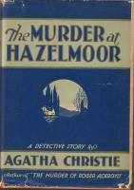

Dust-jacket illustration of the US first edition
Christie A. The murder at Hazelmoor. New York: Dodd, Mead and company, 1931

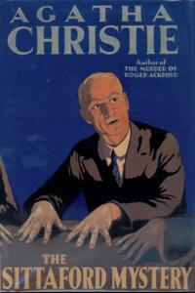

Dust-jacket illustration of the UK first edition
Christie A. The Sittaford mystery. London: Collins crime club, 1931

