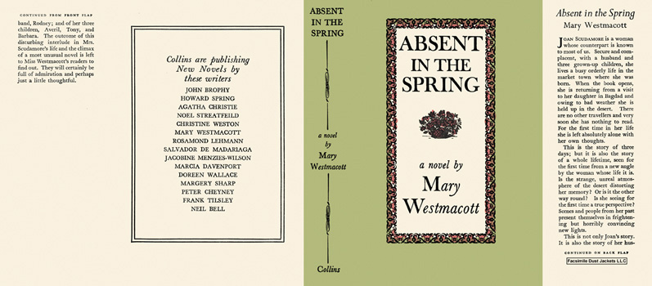

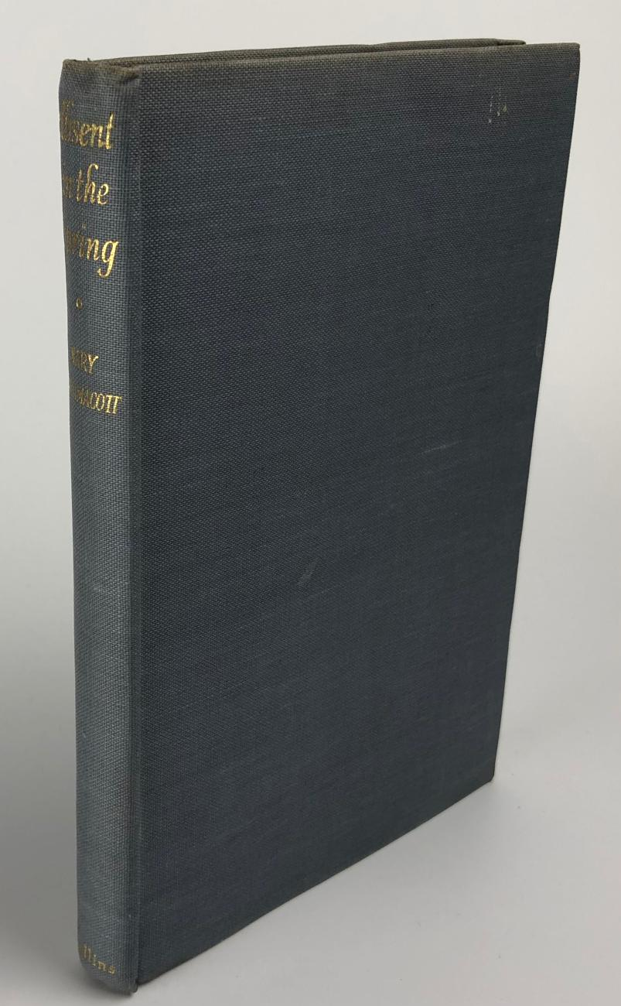

Westmacott, Mary
Absent in the Spring
Collins (UK) (1944) first printing

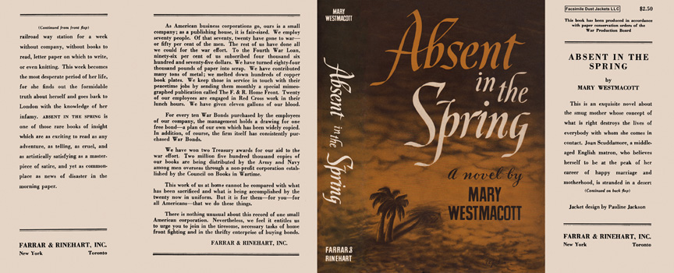

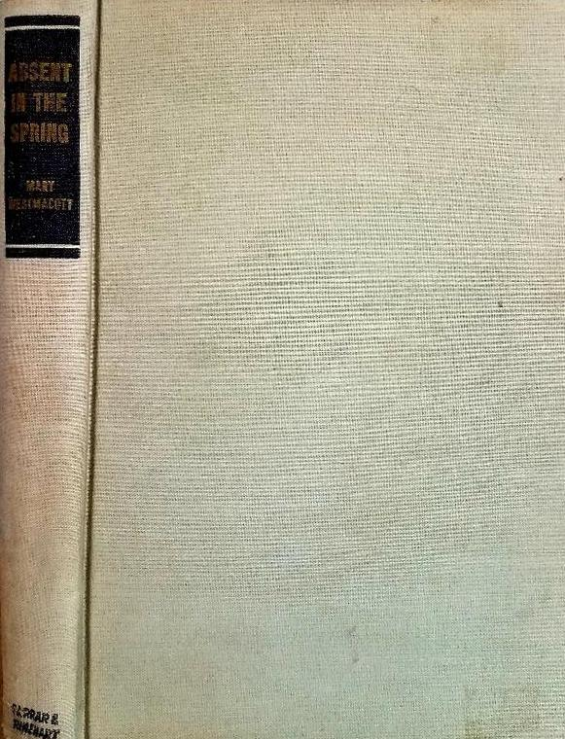

Westmacott, Mary
Absent in the Spring
Farrar & Rinehart, Inc. (USA) (1944) first printing

Суперобложки и внешний вид первых изданий книги

