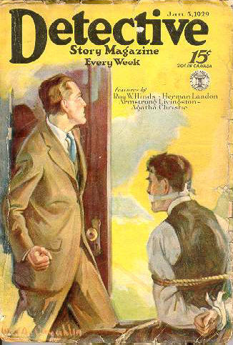

Detective Story Magazine, v 106, N 6 (January 5, 1929)
  - 1 · The Crooked Street · Roy W. Hinds
  - 39 · In the Third Floor Flat [Hercule Poirot] · Agatha Christie; also appeared in Hutchinson’s Story Magazine, January 1929 as “The Third Floor Flat”.
  - 50 · The Silent Watch [Part 2 of 3; Martin Dale (The Picaroon)] · Herman Landon; not the same as the story of the same name in the July 30, 1921 issue.
  - 72 · When Is a Pistol Not a Pistol? · Anon.
  - 73 · Shot with Gold [“Big Scar” Guffman] · Henry Leverage
  - 82 · Royal Mounted Got Their Man · Anon.
  - 83 · The Jeweled Trap [Part 4 of 6] · Armstrong Livingston
  - 103 · Aviation Aids in Capture · Anon.
  - 104 · When Justice Comes to Grips with Crime: The Verdict · Charles R. Rosenberg, Jr.
  - 109 · Stolen Goods That “Talked” · Anon.
  - 110 · Perfect Frame · Edward Leonard
  - 120 · No Sob-Sister Stuff · M. I. H. Rogers
  - 131 · A Bullet Which Turns Corners · Anon.
  - 132 · What Constitutes Legal Insanity? · D. C. Hubbard
  - 134 · Looting a Fur Store with Paint · Anon.
  - 134 · What Handwriting Reveals · Shirley Spencer
  - 137 · Shooting Stars · Anon.
  - 138 · Under the Lamp · Helen Asbury
  - 139 · Here’s a Chance · Anon.
  - 140 · Headquarters Chat · [The Editor]
  - 142 · Missing · [Various]
Обложка журнала с первой публикацией рассказа

