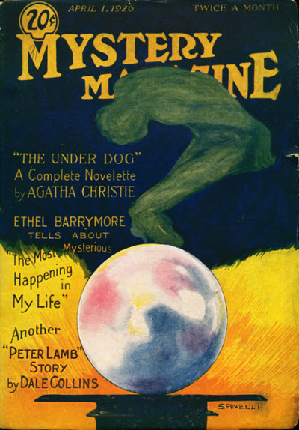

Mystery Magazine, v 8, N 6 (April 1, 1926)
  - The Under Dog [Hercule Poirot] · Agatha Christie
  - A Slight Misapprehension [Peter Lamb] · Dale Collins
  - Who? · Richard Howells Watkins
  - A Bon Marche · William Merriam Rouse
  - Sinister House [Part 2 of 4] · Charles G. Booth
  - The Crest · M. G. Roberts
  - Bayou · Haynes Irebor
  - Talking About Snakes · Neil McPhee

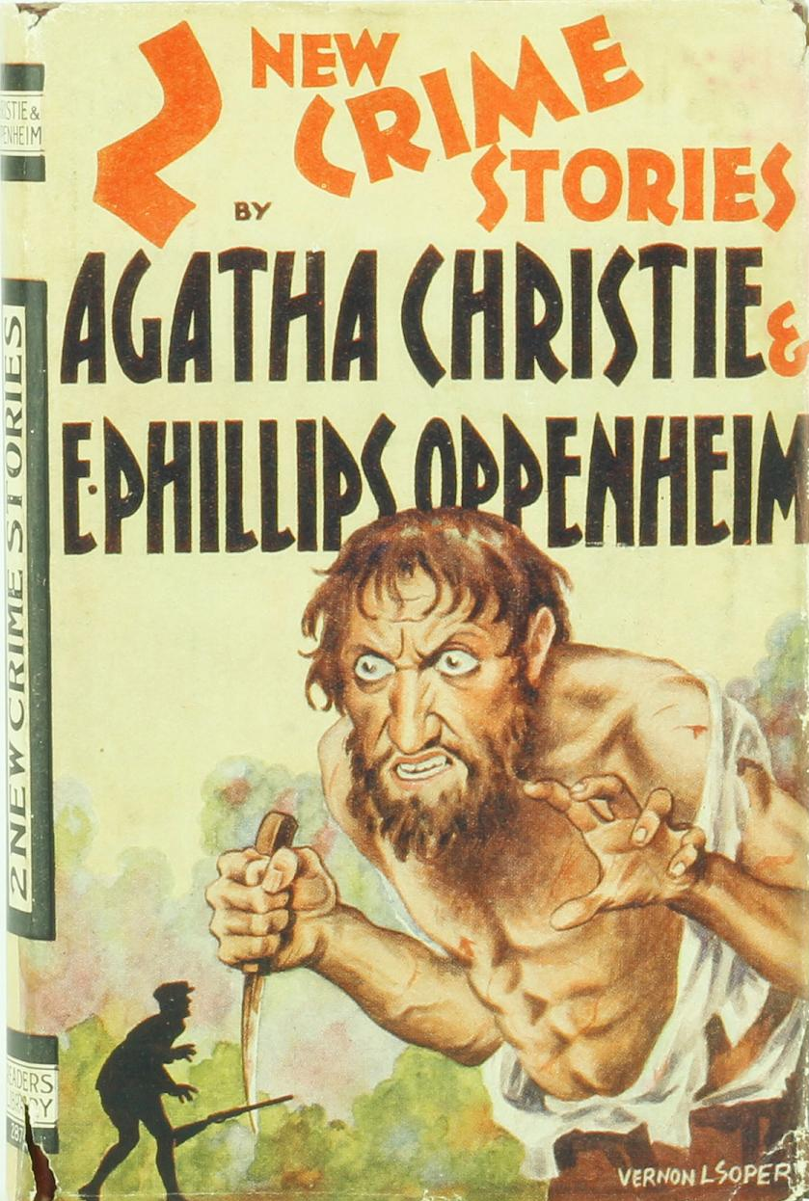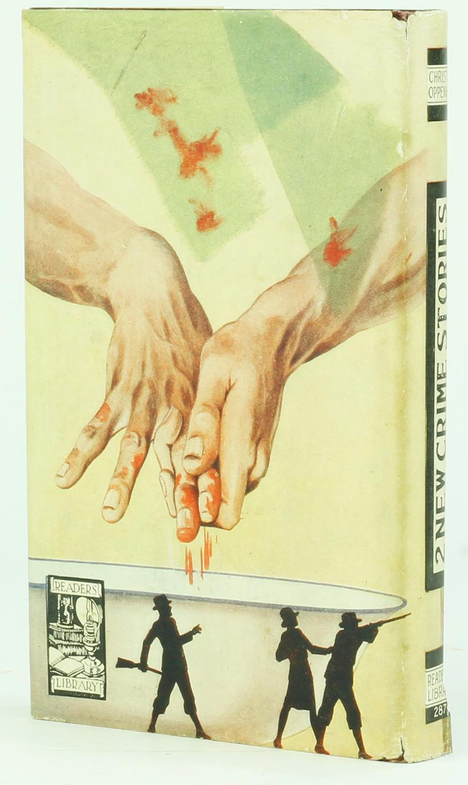

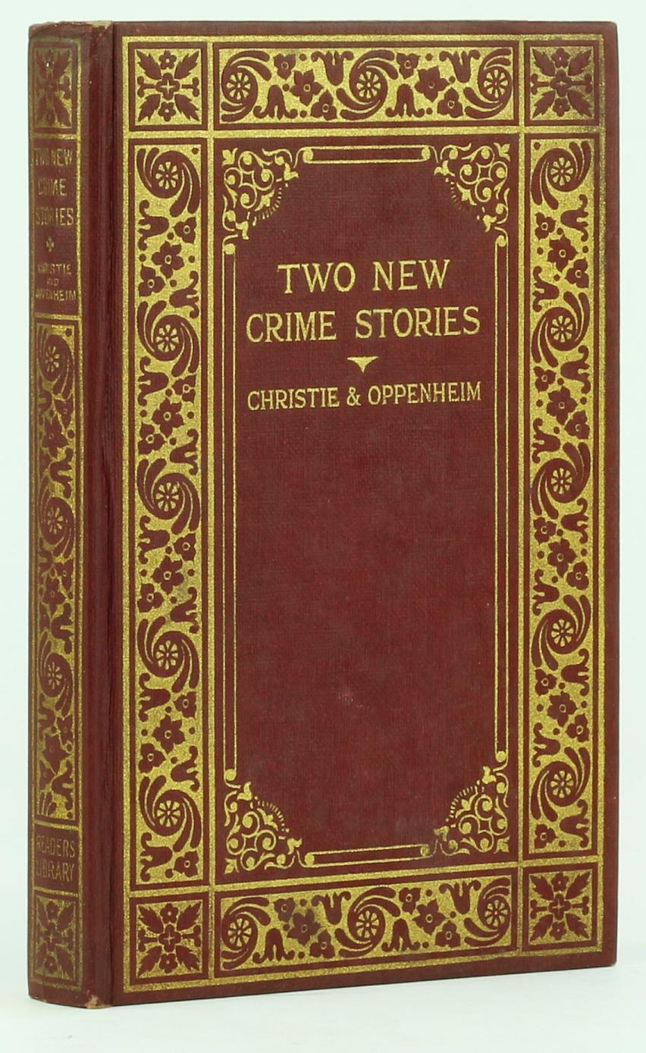

CHRISTIE, Agatha

PHILLIPS OPPENHEIM, E.

UNDER DOG and BLACKMAN'S WOOD
Published by Reader's Library, 1929

Обложки и внешний вид первых изданий повести

