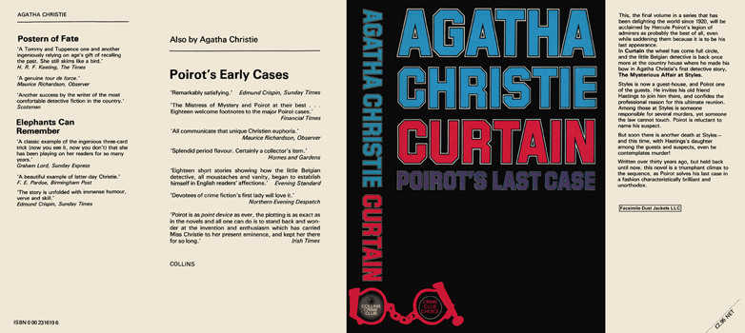

Christie, Agatha
Curtain: Poirot’s last case
Collins The Crime Club (UK) (1975) first printing

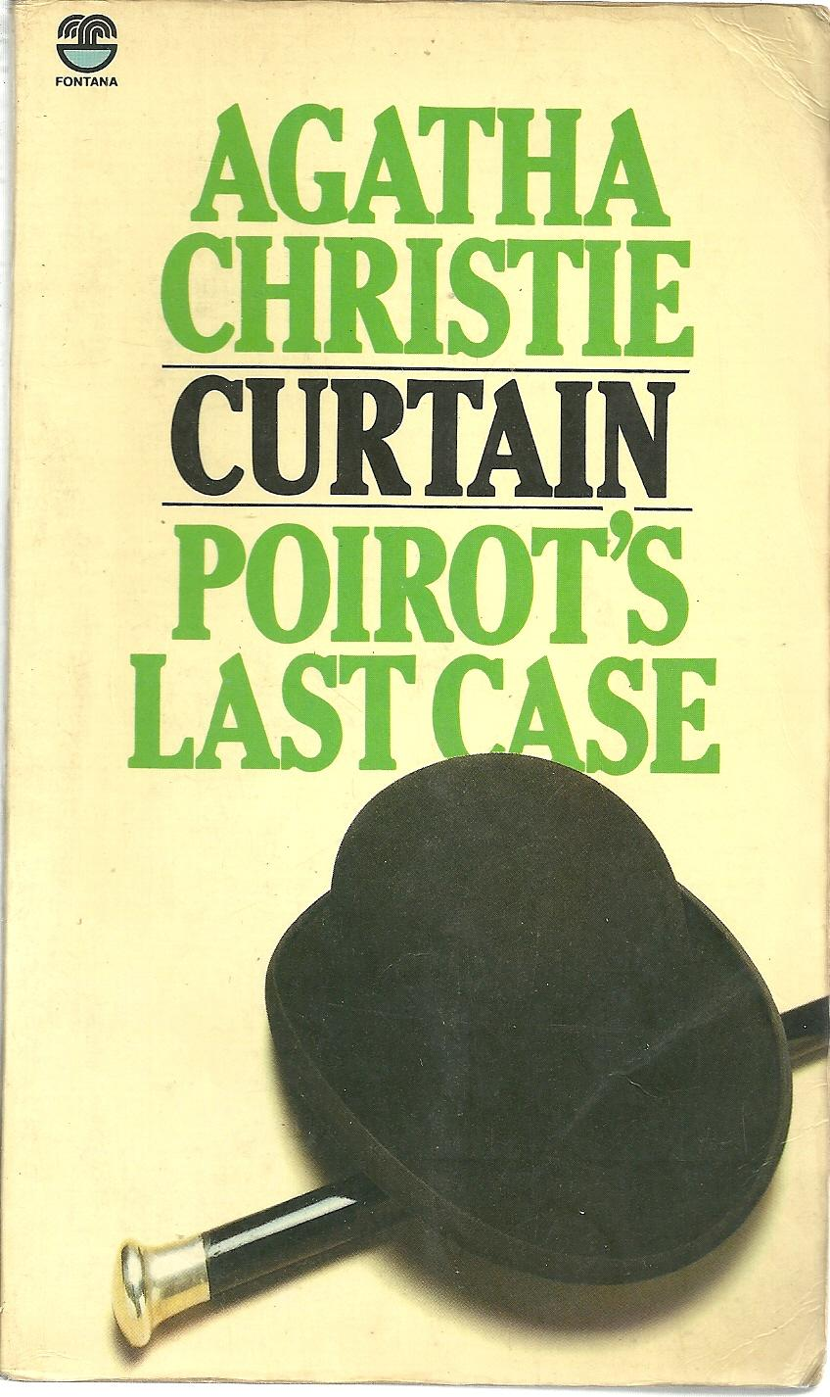

Christie, Agatha
Curtain: Poirot’s last case
Fontana Books, Glasgow (1976)

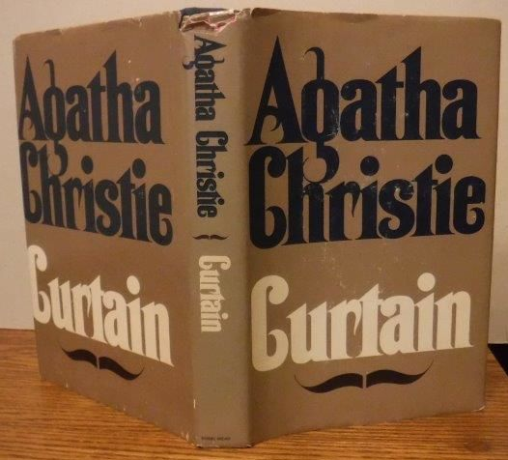

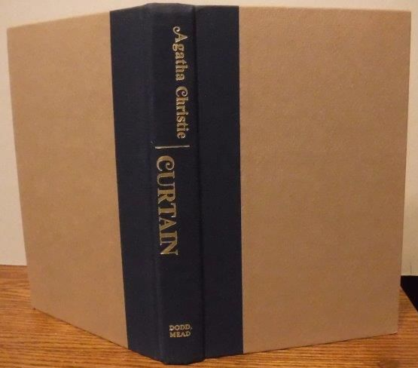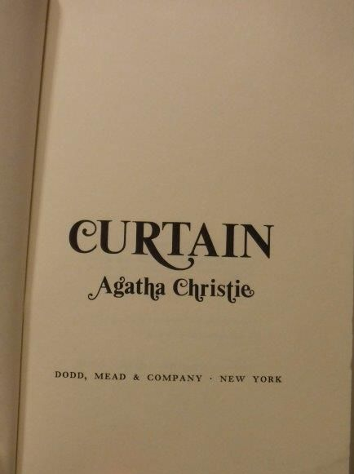

Christie, Agatha
Curtain: Poirot’s last case
New York: Dodd Mead (1975)



Christie, Agatha
Curtain: Poirot’s last case
Dodd Mead and Company, London, Surrey, United Kingdom (1975)

Суперобложки и внешний вид первых изданий книги

