

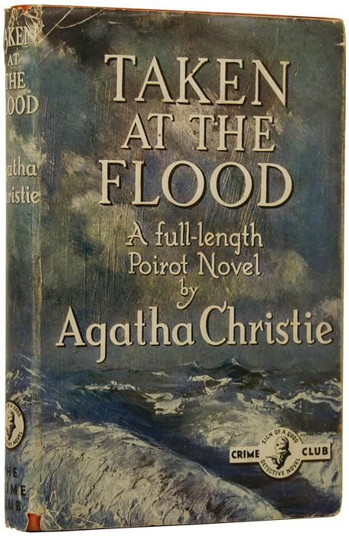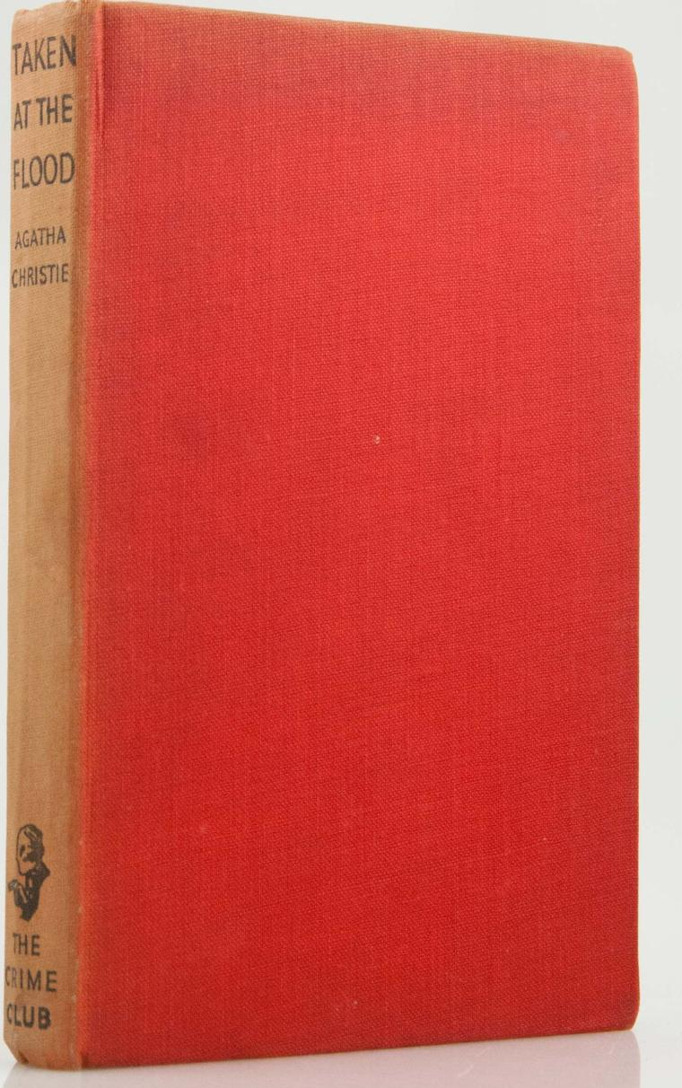

Christie, Agatha
Taken at the flood
Collins The Crime Club (UK), 1948
first printing

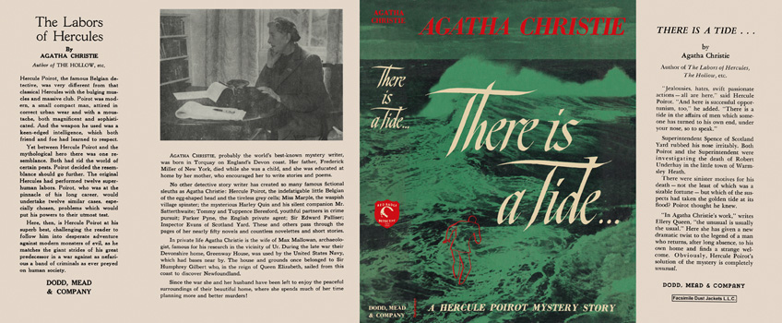

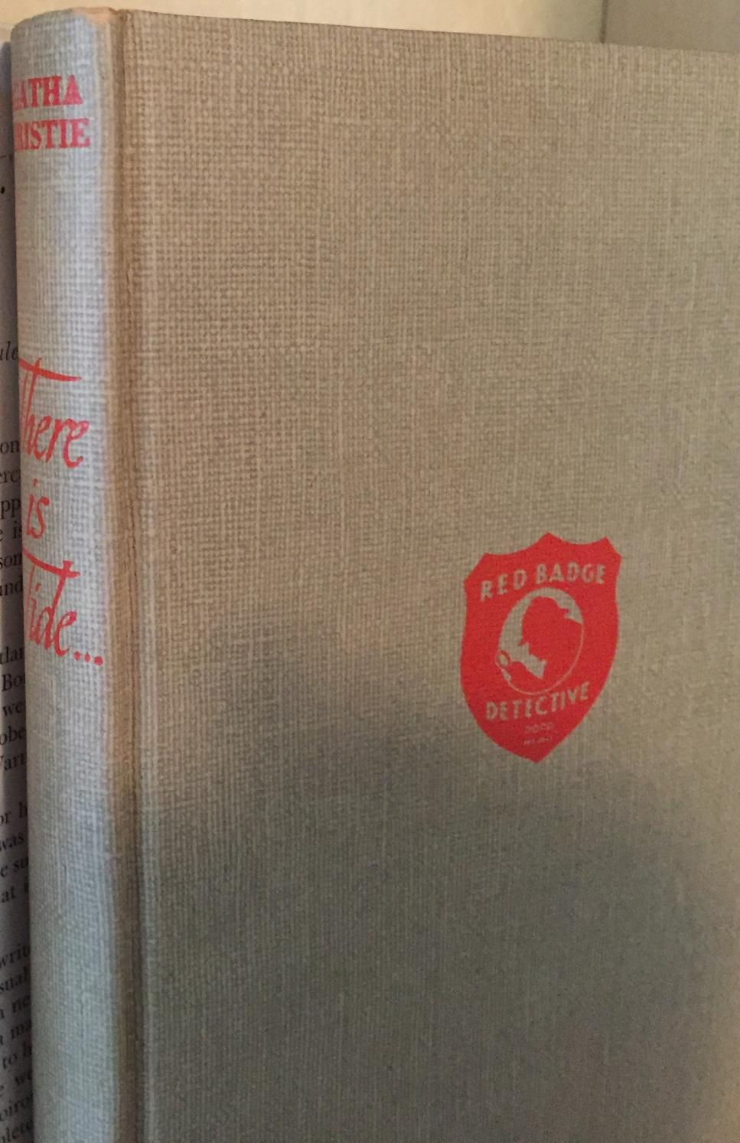

Christie, Agatha
There is a tide
Dodd, Mead & Company (USA), 1948
first printing

Суперобложки и внешний вид первых изданий романа

