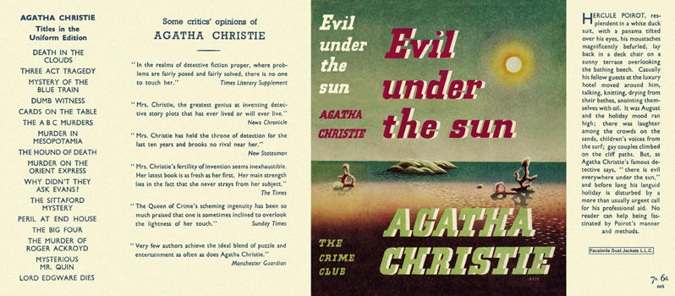

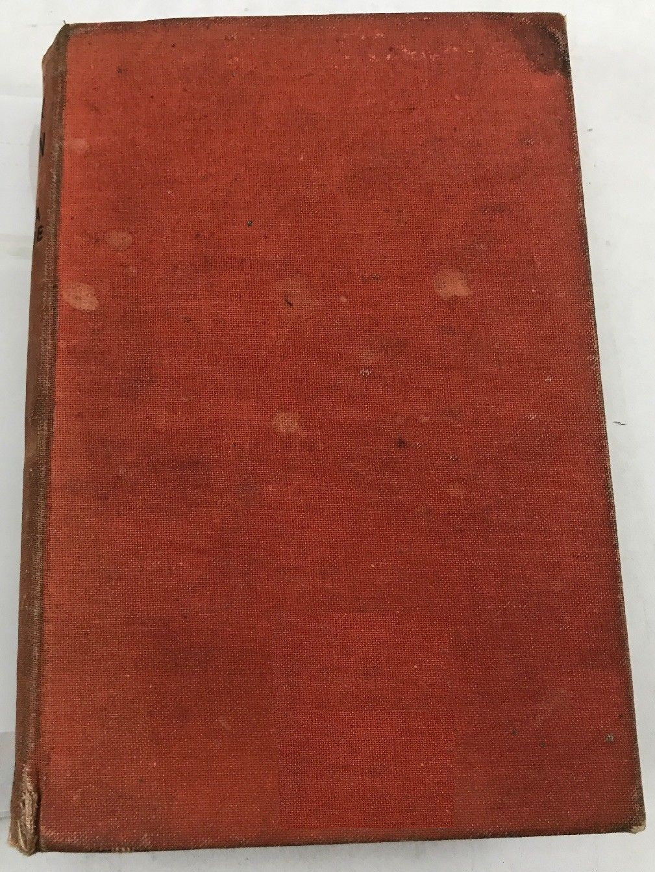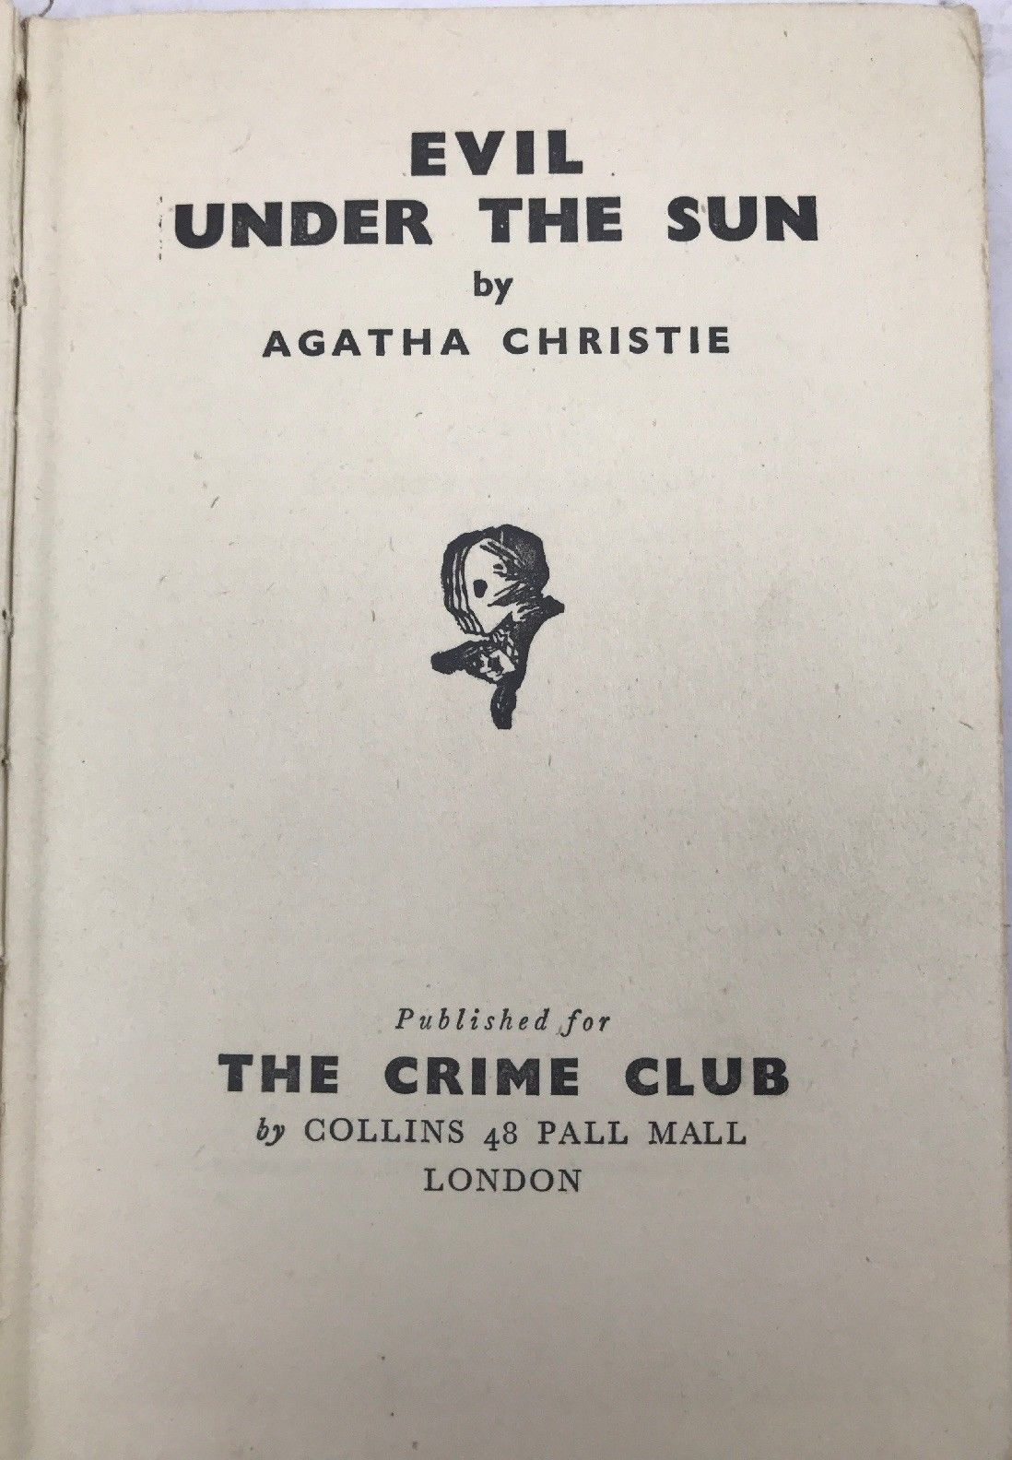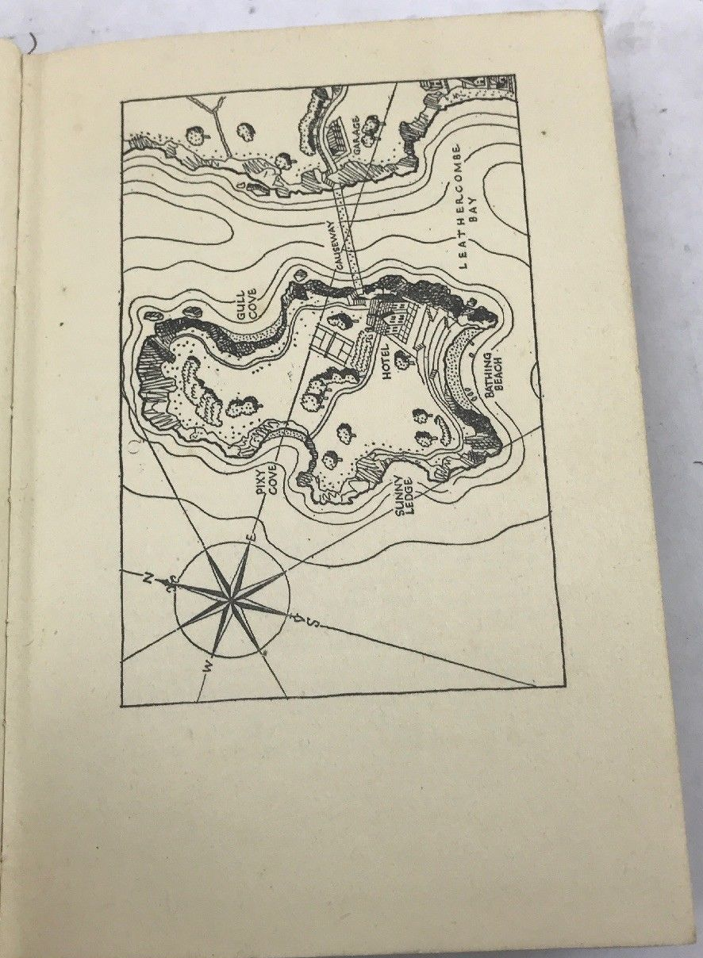

Christie, Agatha
Evil under the sun
Collins The Crime Club (UK) (1941) first printing

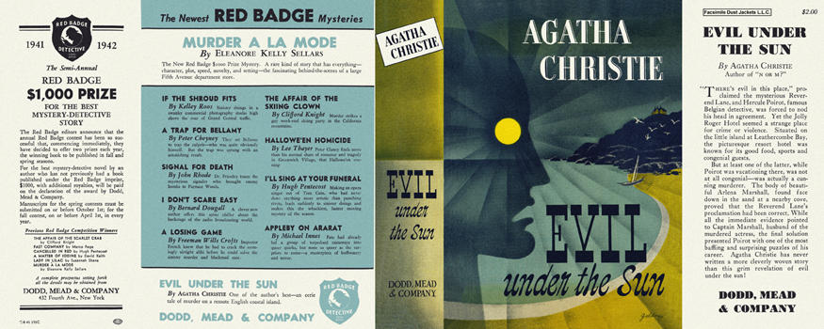

Christie, Agatha
Evil under the sun
Dodd, Mead & Company (USA) (1941) first printing

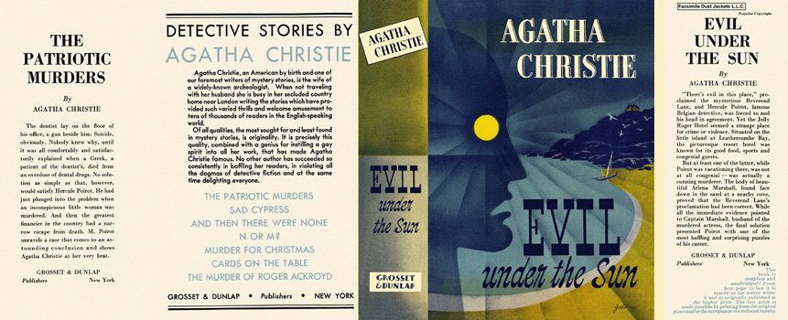

Christie, Agatha
Evil under the sun
Grosset & Dunlap (USA) (1941) reprint

Внешний вид первых изданий книги

