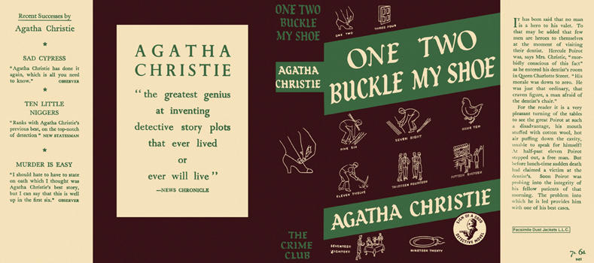

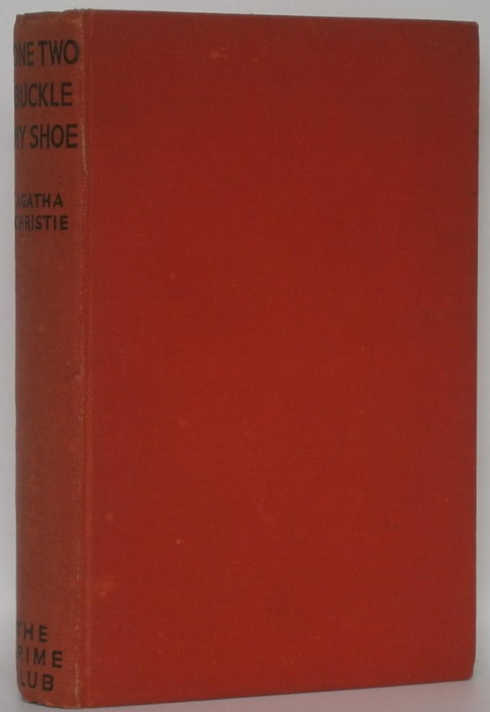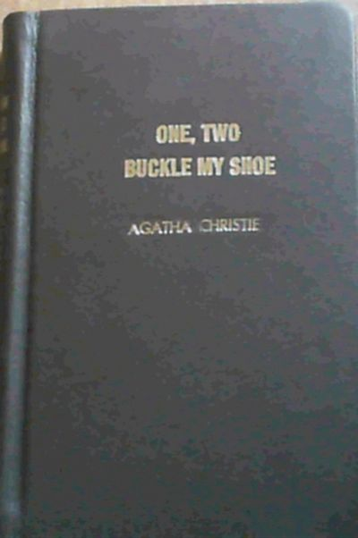

Christie, Agatha
One, two, buckle my shoe
Collins The Crime Club (UK) (1940) first printing

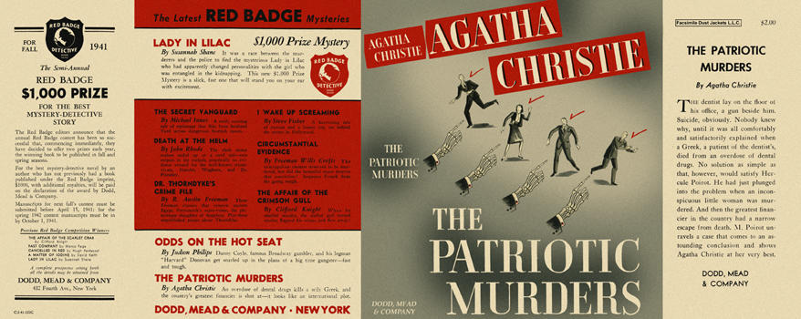

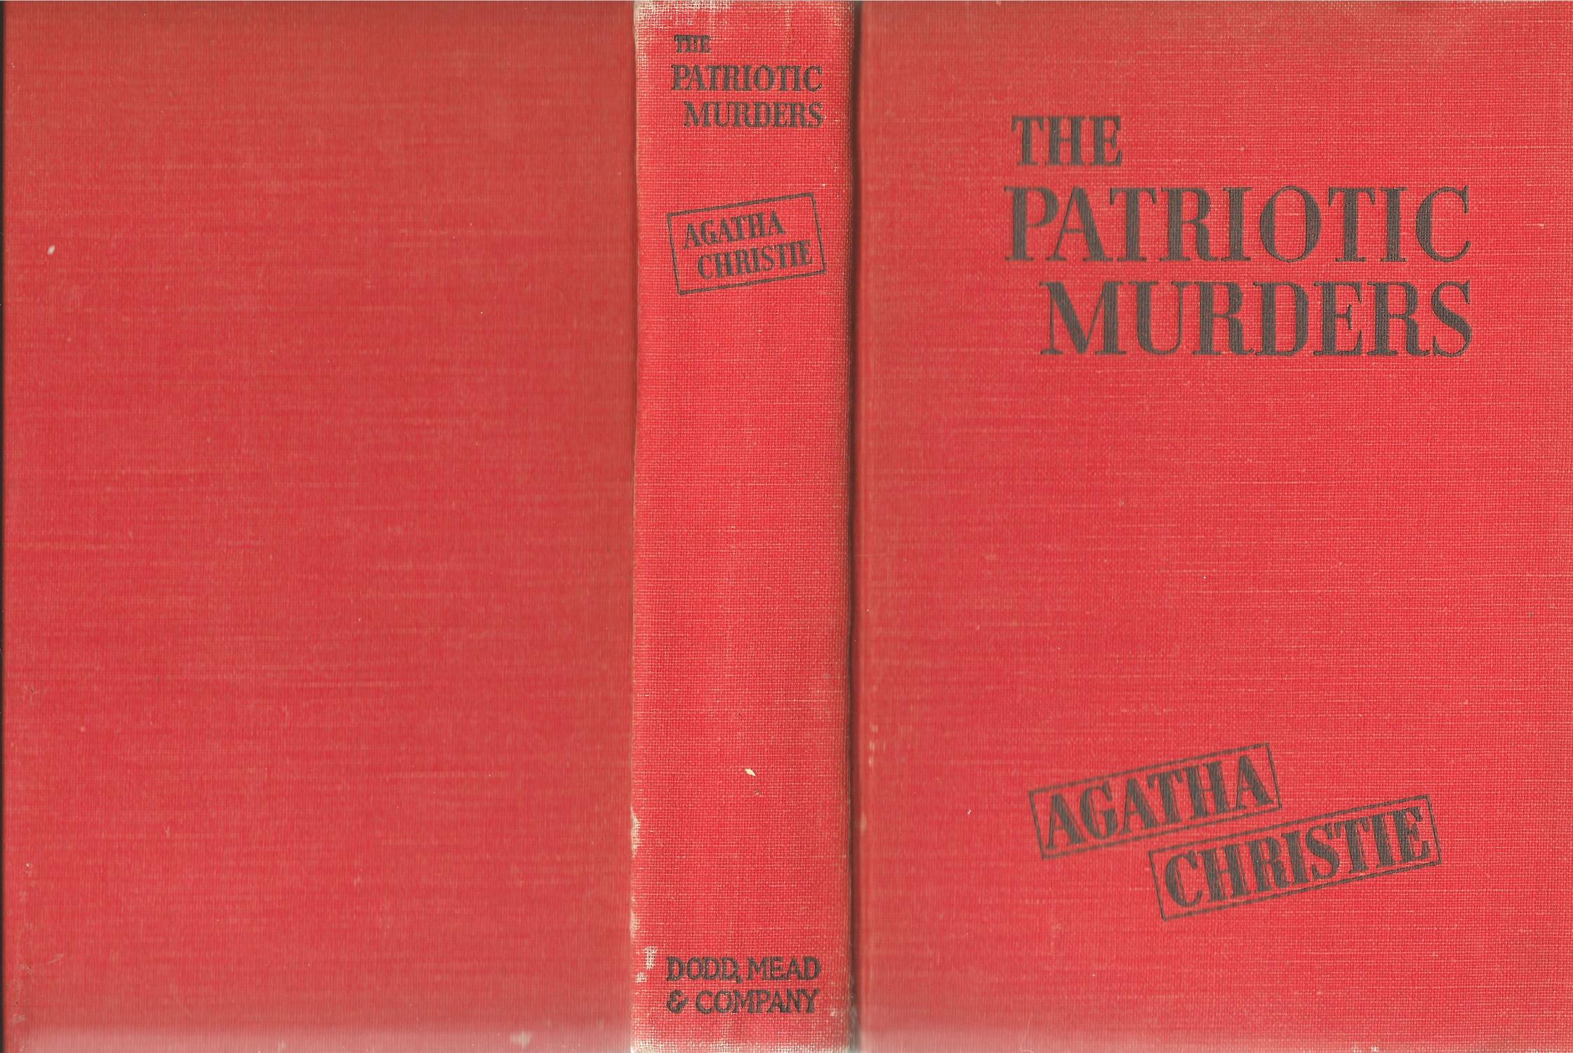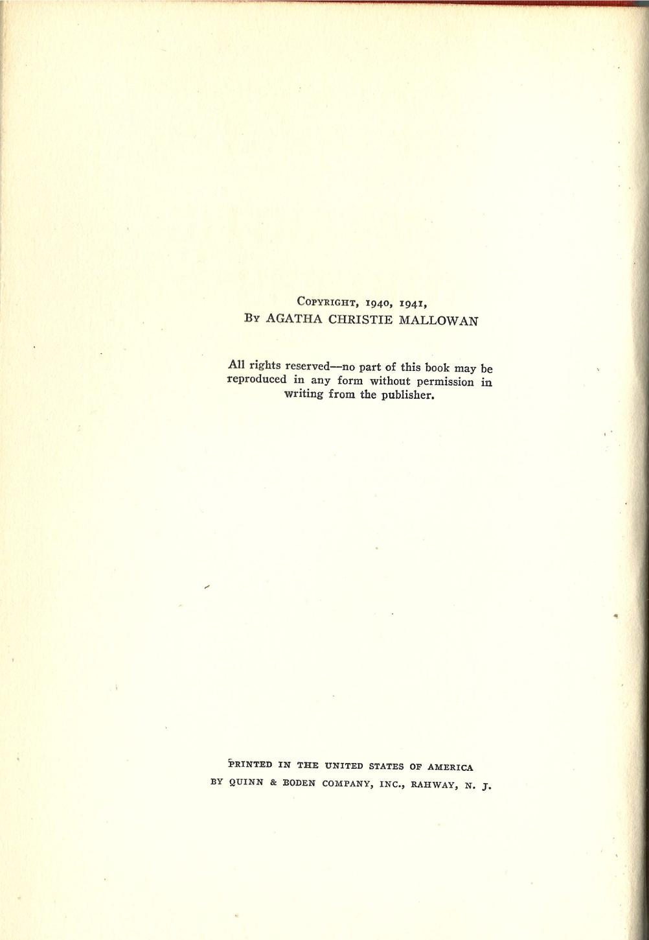

Christie, Agatha
The patriotic murders
Dodd, Mead & Company (USA) (1941) first printing

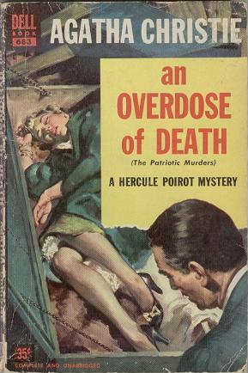

Christie, Agatha
An overdose of death
A Dell Book/ Dell Publishing Co Inc., New York, (USA) (1941) first printing

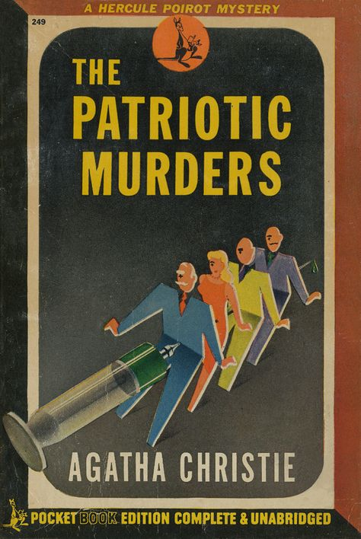

Christie, Agatha
The patriotic murders
Pocket Books Edition (USA) (1943) first printing

Внешний вид первых изданий книги

