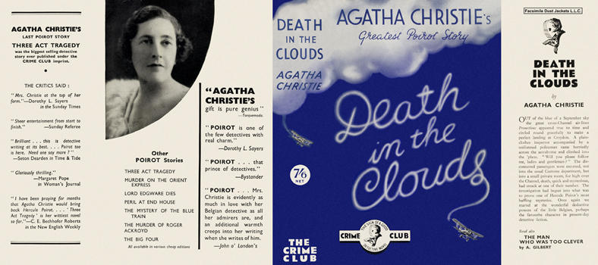

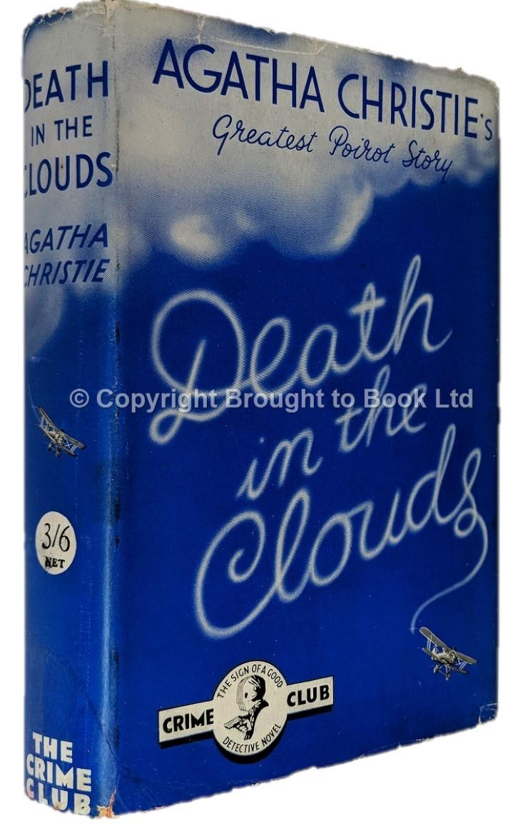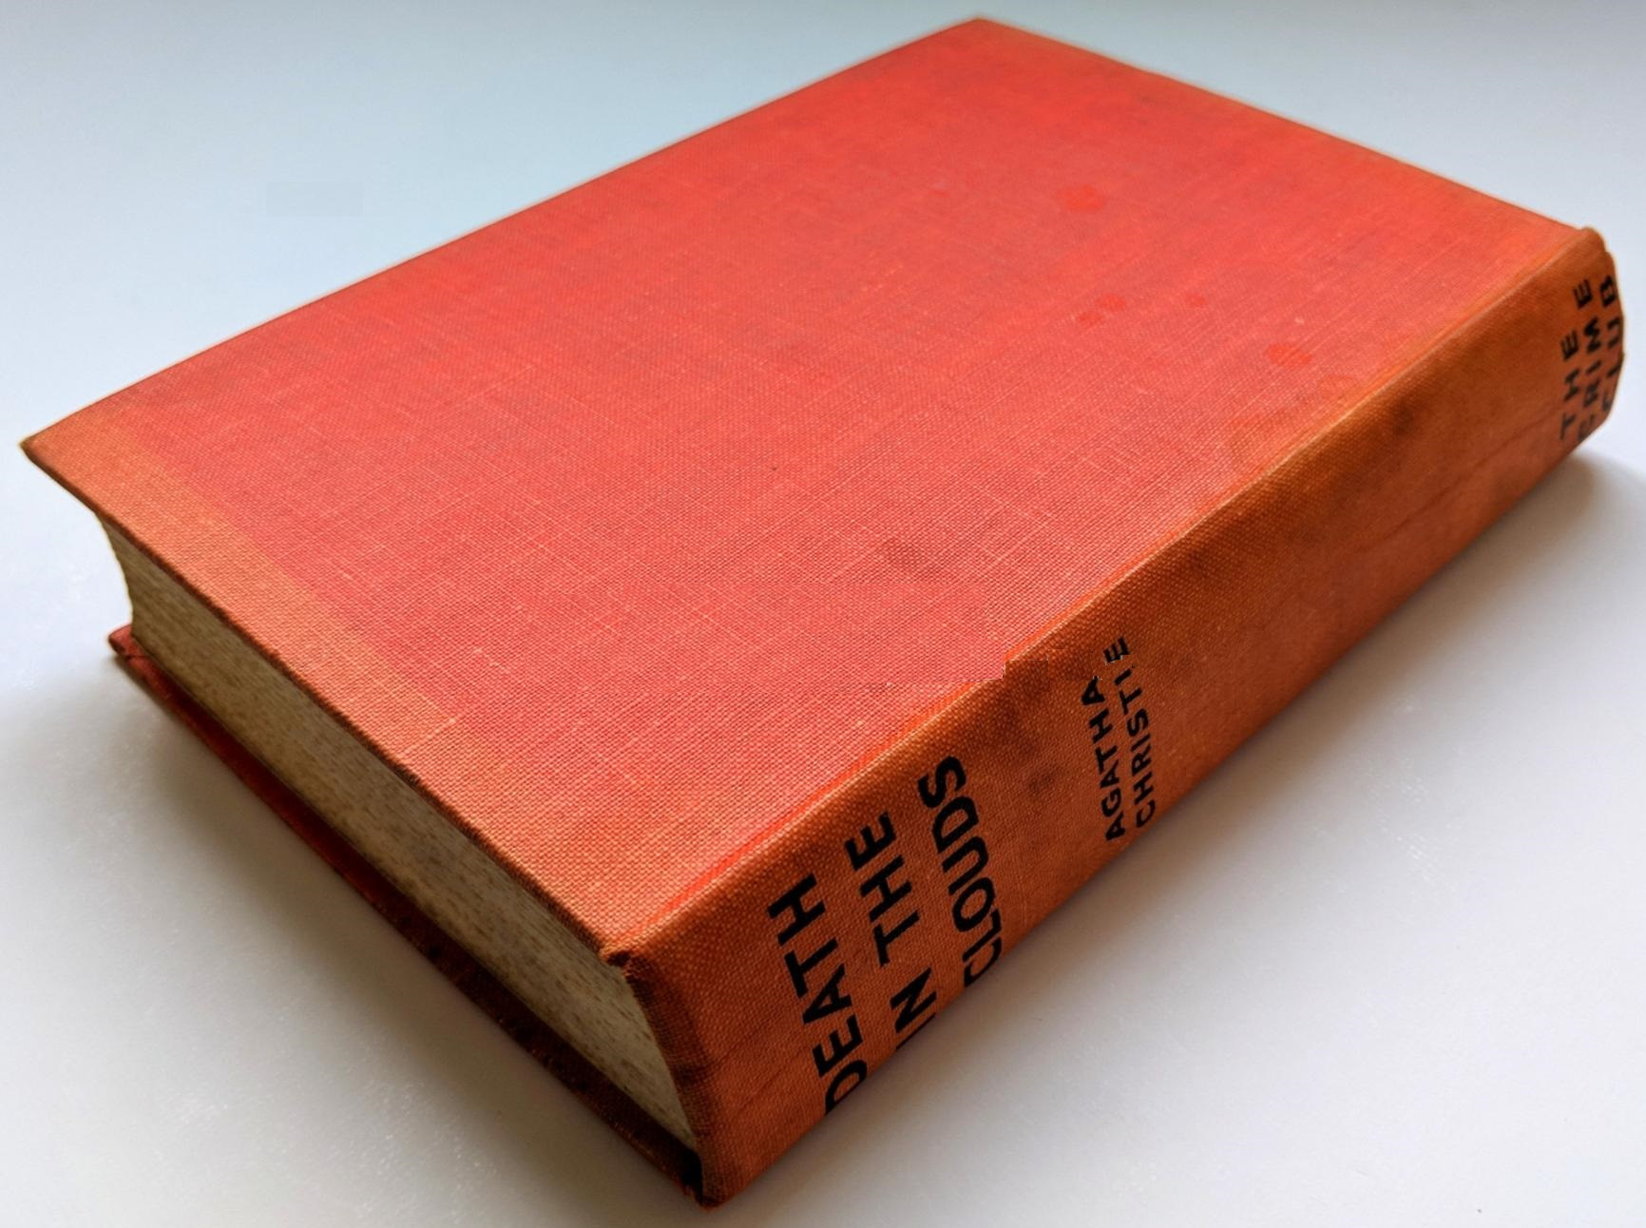

Christie, Agatha
Death in the clouds
Collins The Crime Club (UK) (1935) first printing.

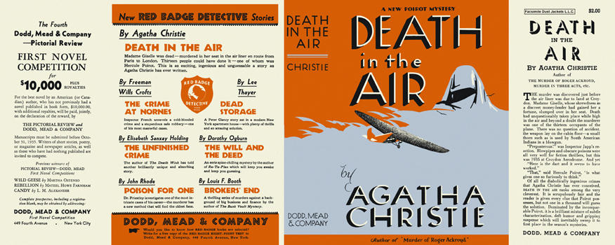

Christie, Agatha
Death in the air
Dodd, Mead & Company (USA) (1935) first printing.

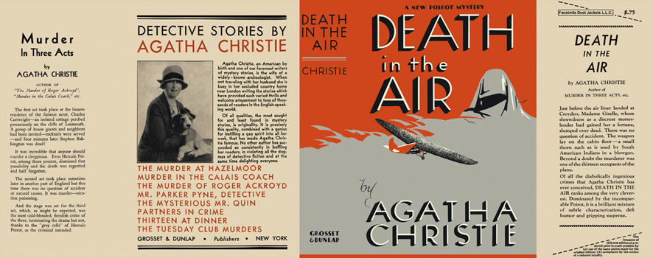

Christie, Agatha
Death in the air
Grosset & Dunlap (USA) (1935) reprint.

Внешний вид первых изданий книги

