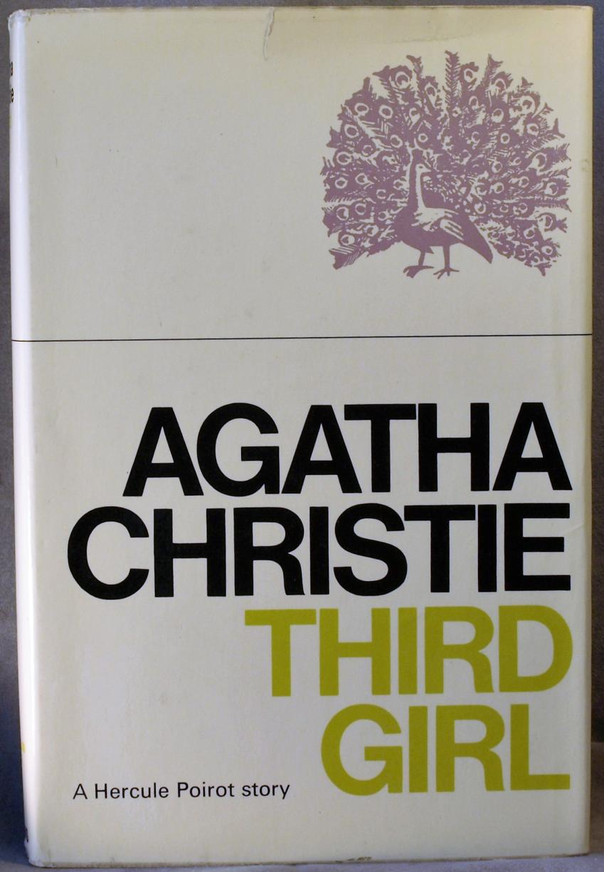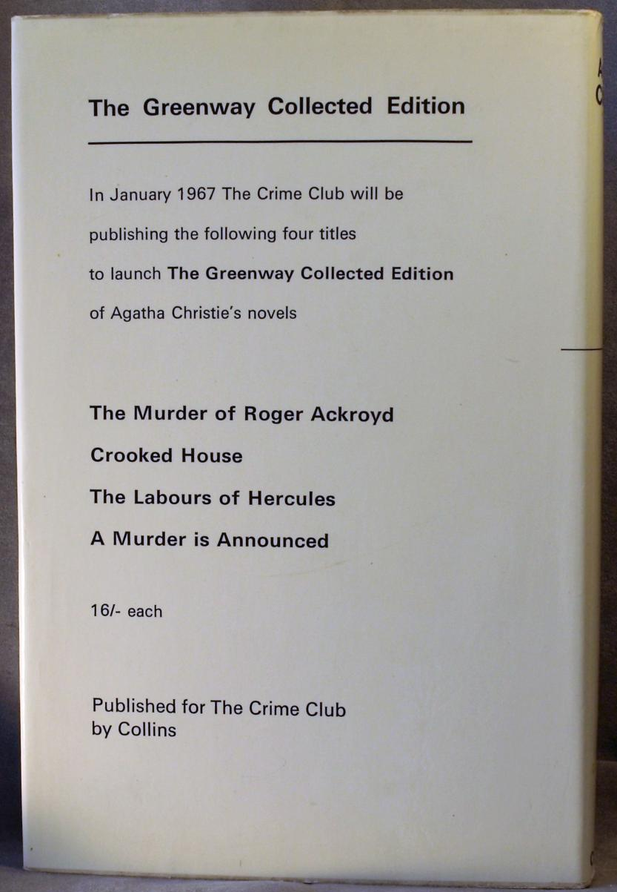
Christie, Agatha
Third girl
Collins Crime Club, London, 1966, first edition

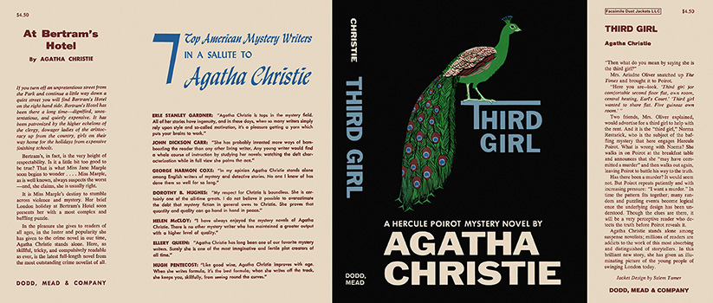
Christie, Agatha
Third girl
Dodd, Mead & Company (USA) (1966) first printing

Внешний вид первых изданий книги

