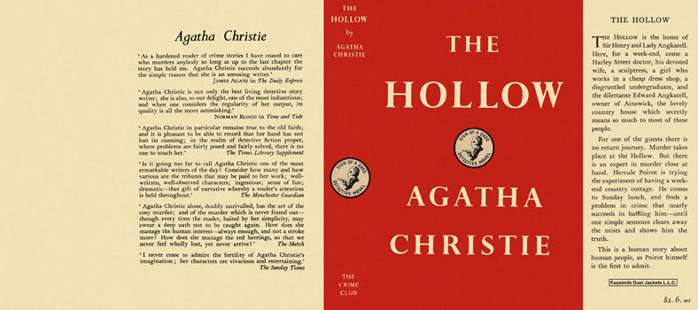

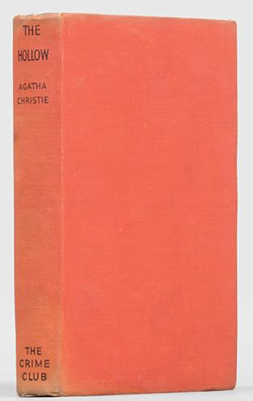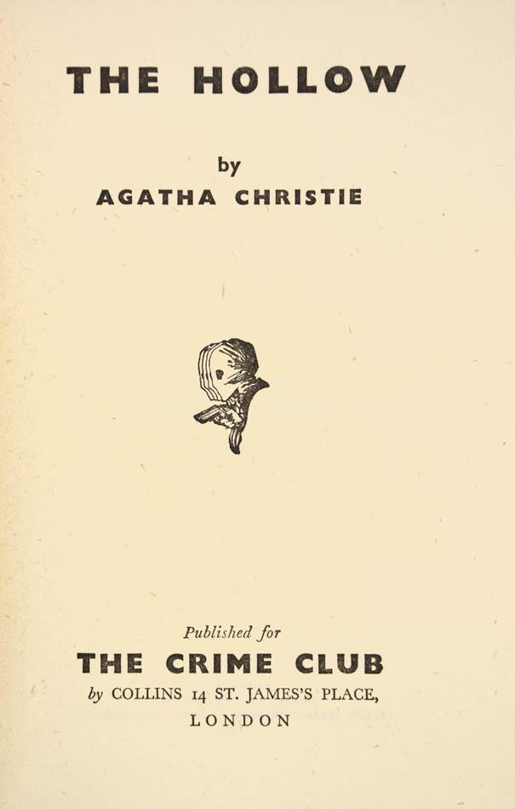

Christie, Agatha
The Hollow
Collins The Crime Club (UK) (1946) first printing
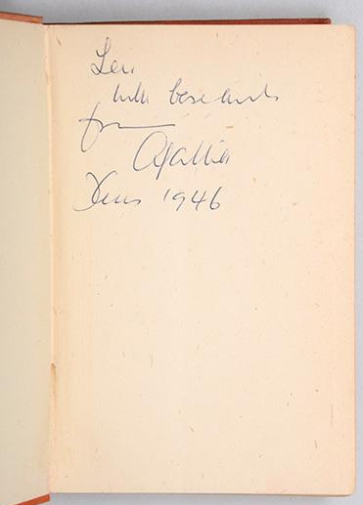
Presentation copy inscribed by the author to Sir Leonard Woolley on the front free endpaper, "Len, with best wishes, from, Agatha, Xmas 1946". Sir Leonard and his wife Katharine were good friends of Christie and her second husband, the archaeologist Sir Max Mallowan.

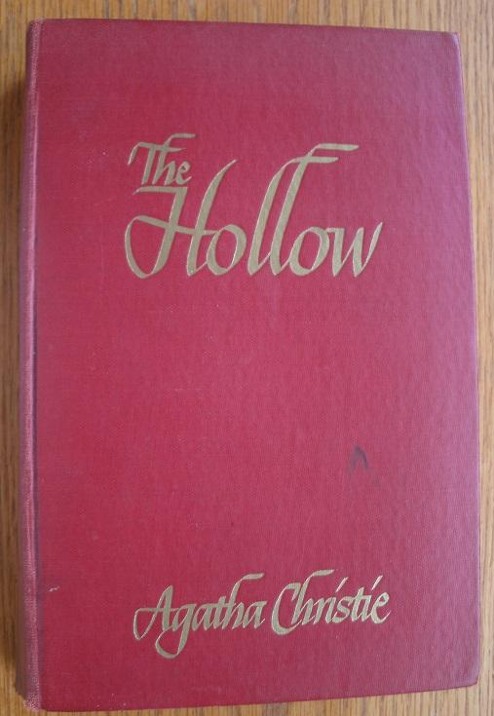

Christie, Agatha
The Hollow
Collins, Toronto (1946) first printing

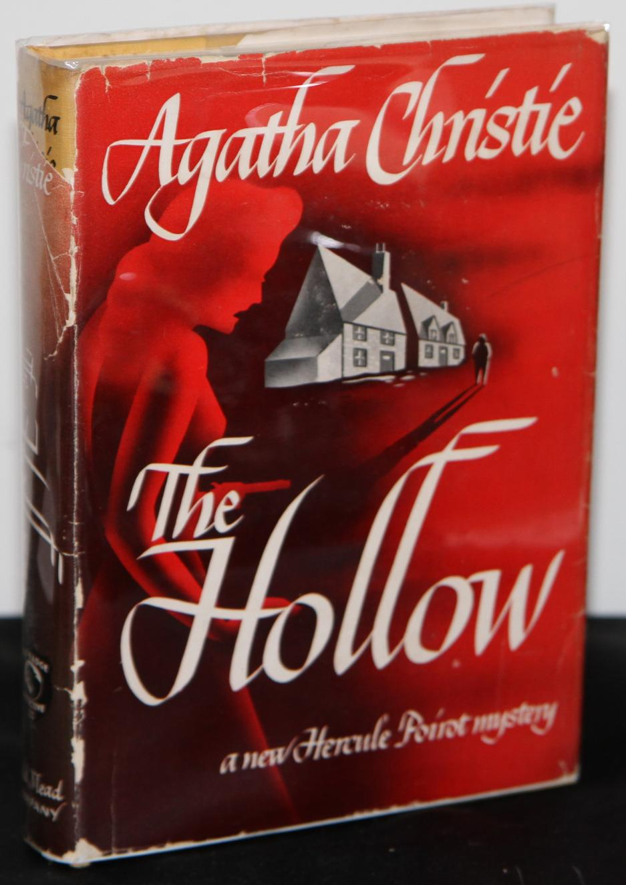
Christie, Agatha
The Hollow
Dodd, Mead and Company, New York, 1946 first printing

Суперобложки и внешний вид первых изданий романа

