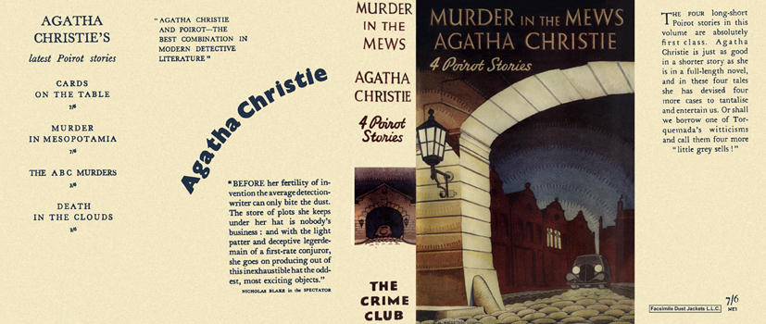
Christie, Agatha

Murder in the mews
Collins The Crime Club (UK) (1937) first printing
4 Poirot stories
Dead man's mirror
The incredible theft
Murder in the mews
Triangle at Rhodes

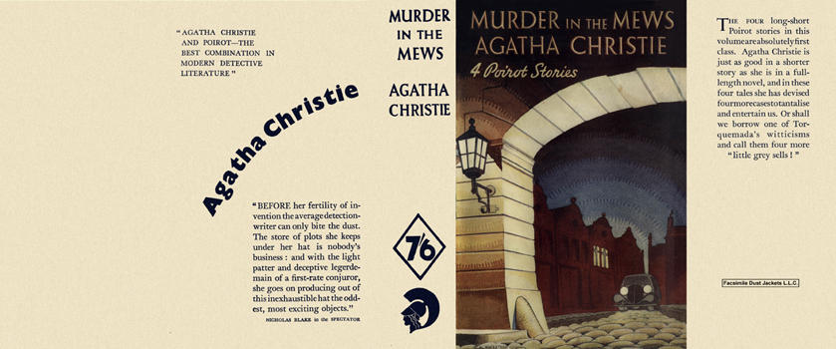
Christie, Agatha

Murder in the mews
Odhams Press (UK) (1937)

Суперобложки первых изданий сборника

