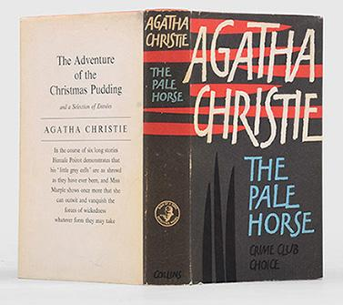
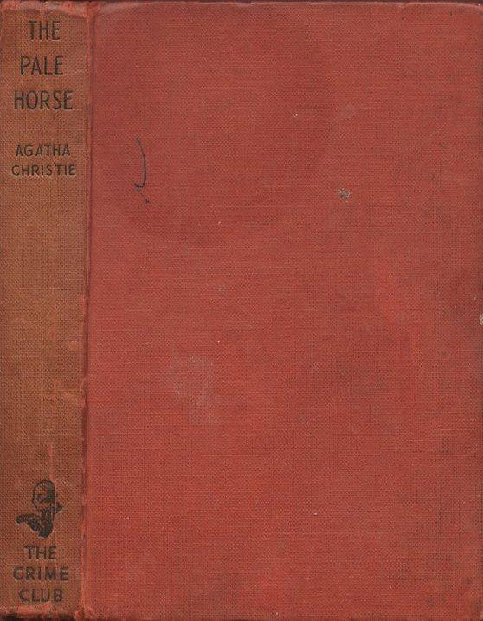

Christie, Agatha

The pale horse
Crime Club, Collins, London (UK) (1961) first printing

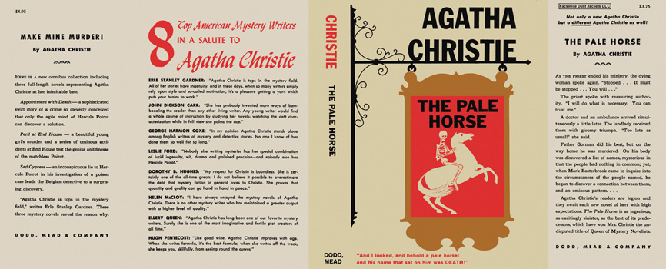

Christie, Agatha

The pale horse
Dodd, Mead and Company (USA) (1962) first printing

Внешний вид первых изданий книги

