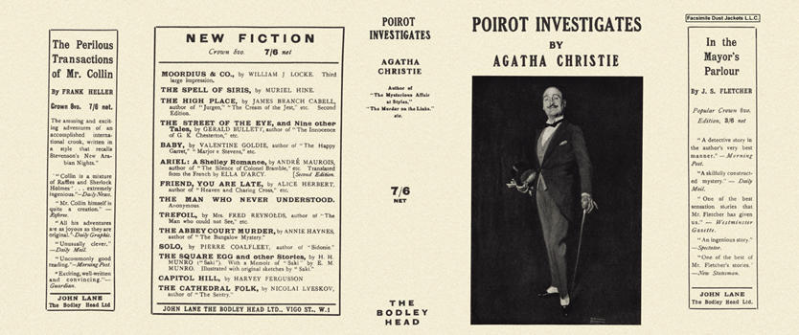

Christie, Agatha

Poirot investigates
John Lane, The Bodley Head (UK) (1924) first printing

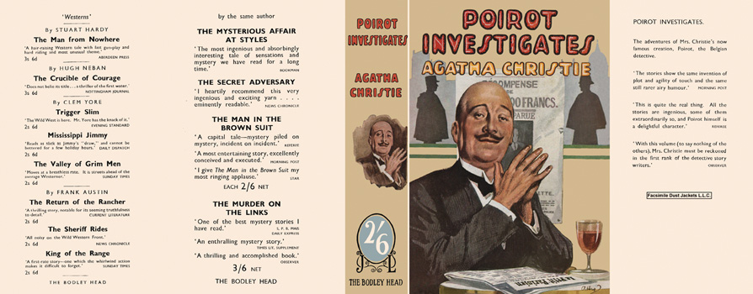

Christie, Agatha
Poirot investigates
John Lane, The Bodley Head (UK) (1924)

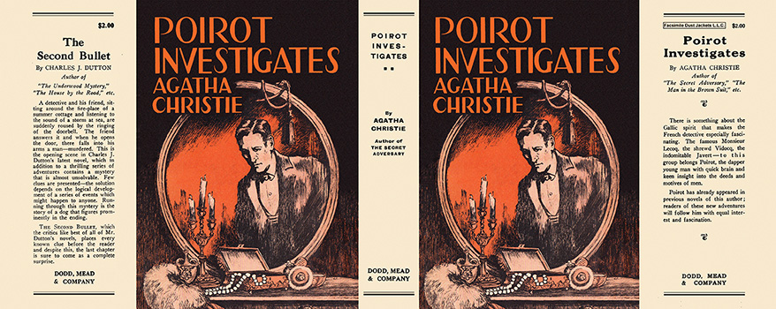

Christie, Agatha
Poirot investigates
Dodd, Mead and company (USA) (1925) first printing

Суперобложки первых изданий сборника

